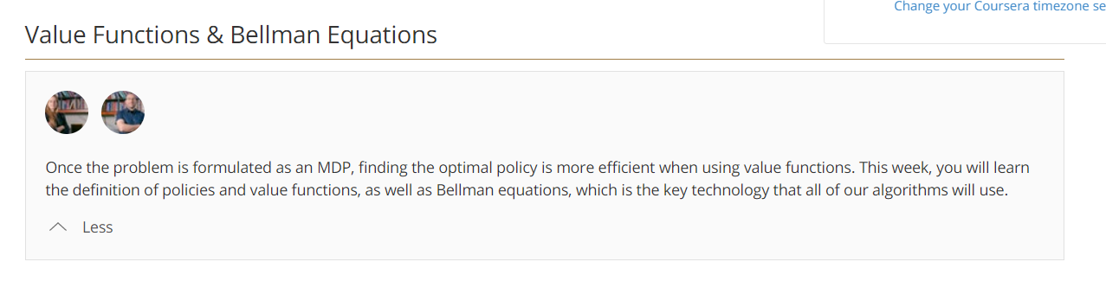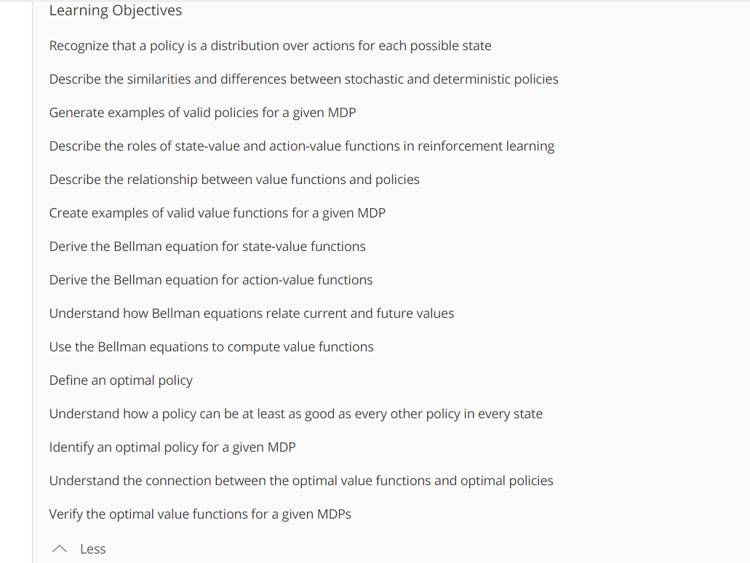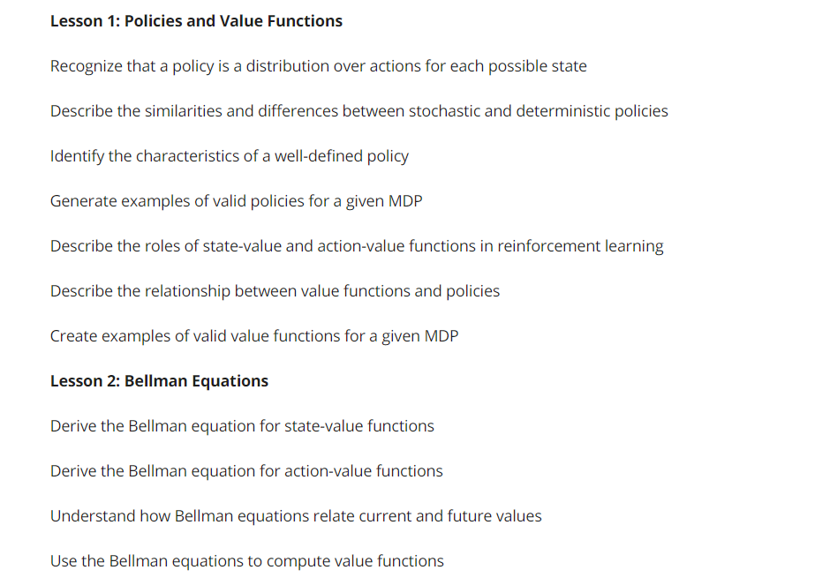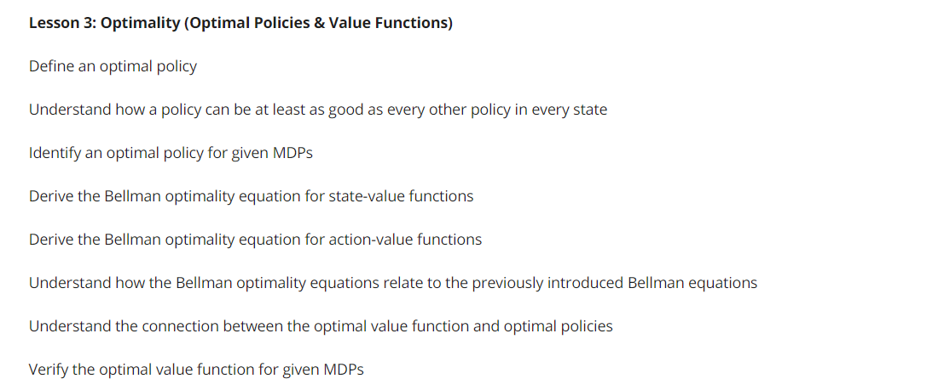

**POLICY:**



Policy : state ------🡪 list of probabilities of actions

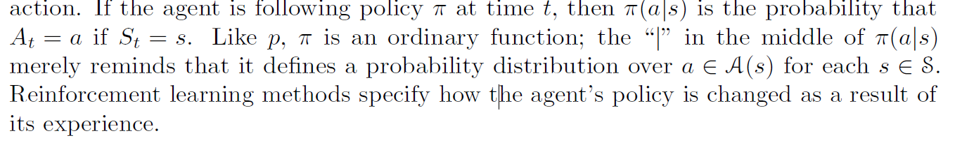

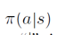 --------------given you are in state s ----select 0 probability action a = that’s policy



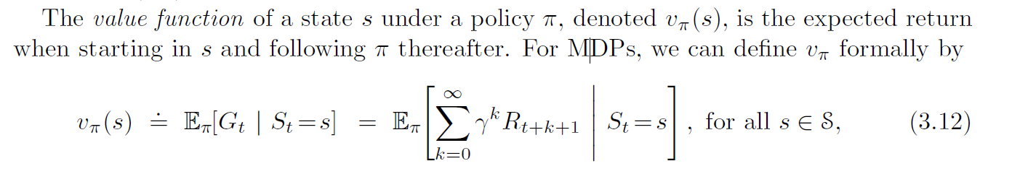

We call the function v⇡ the state-value function for policy ⇡.

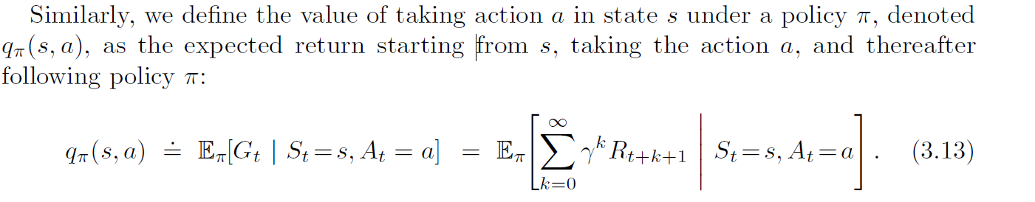



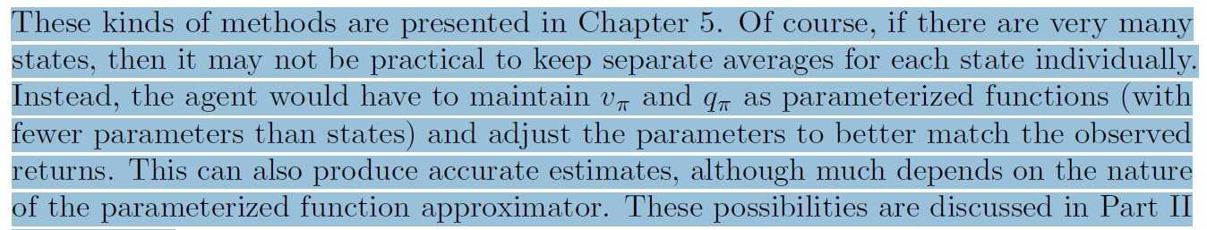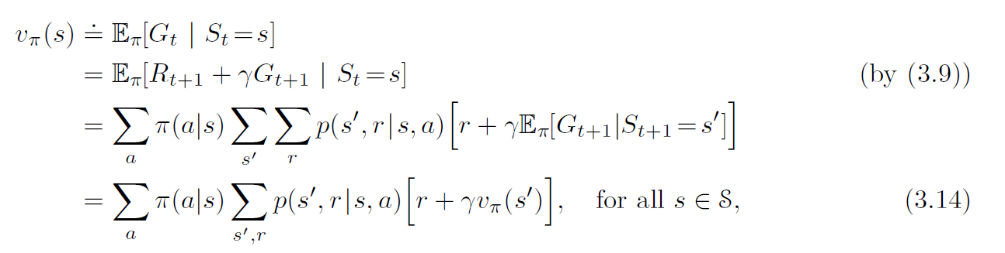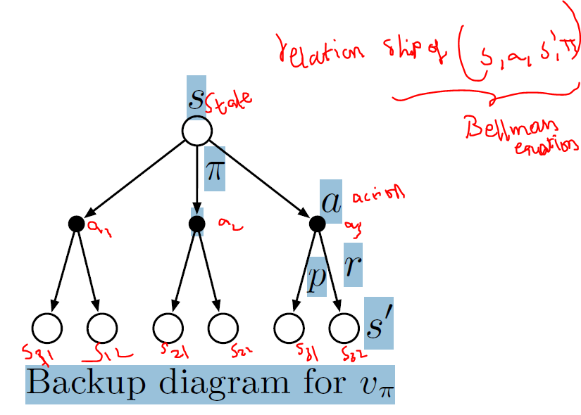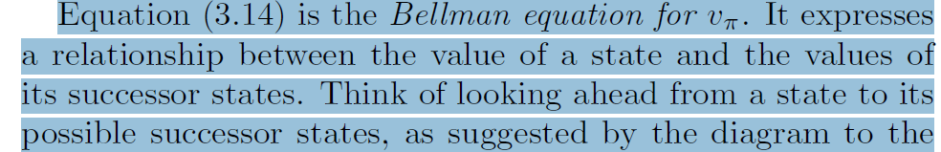

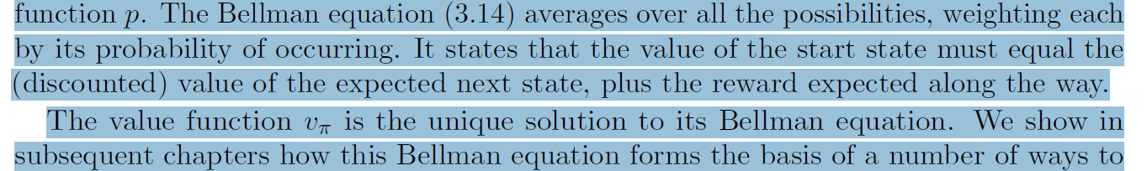

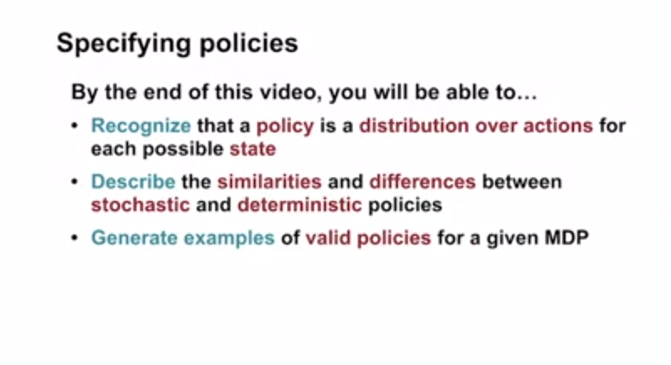 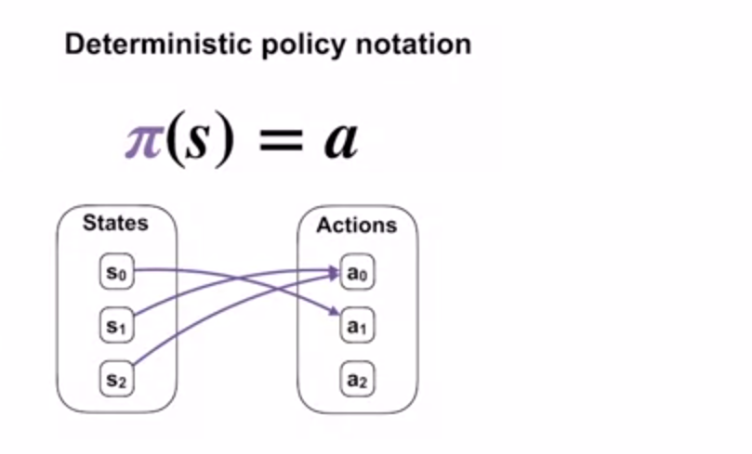 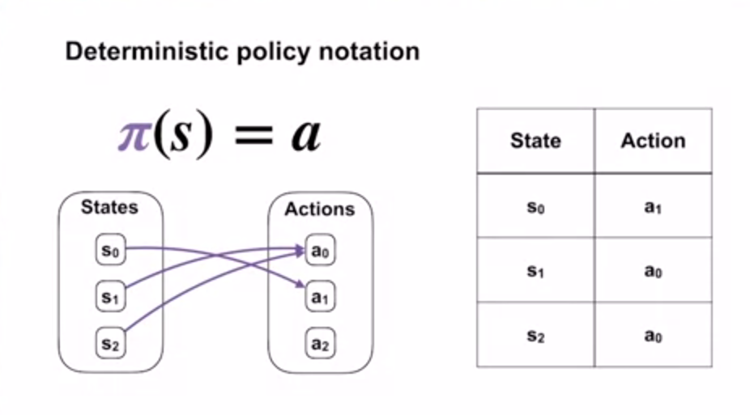 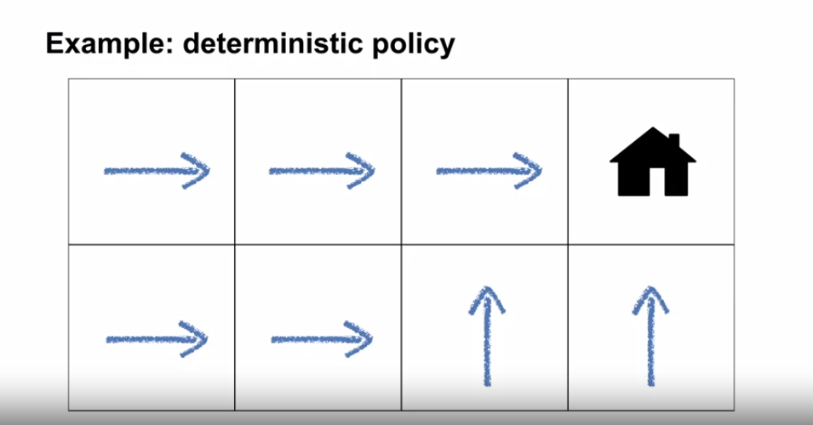

In detreminitsic Each state maps to One action

**stochastic policy notation : Here probabilties are assigned for each action in each state**

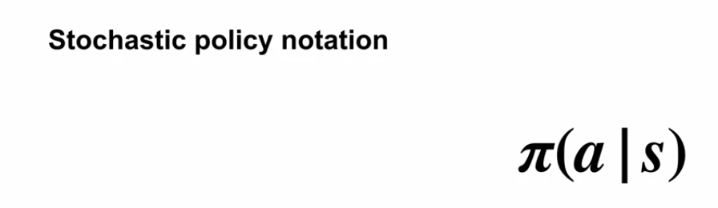 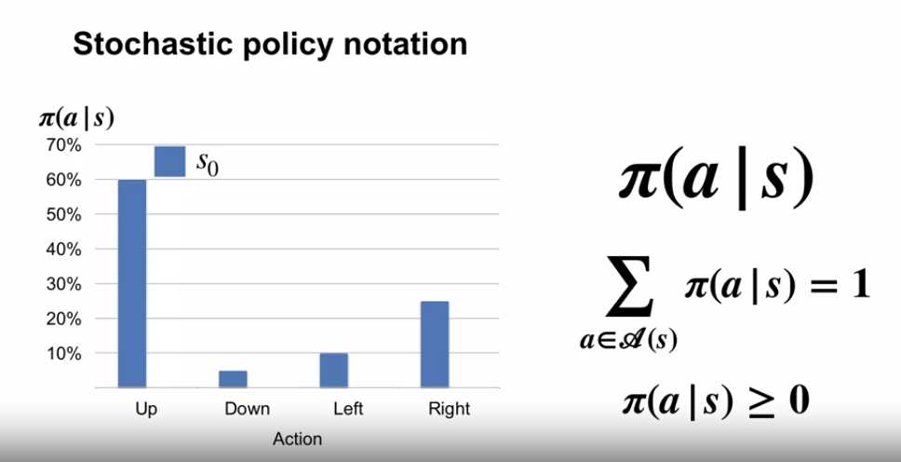

Lets say in other state-1

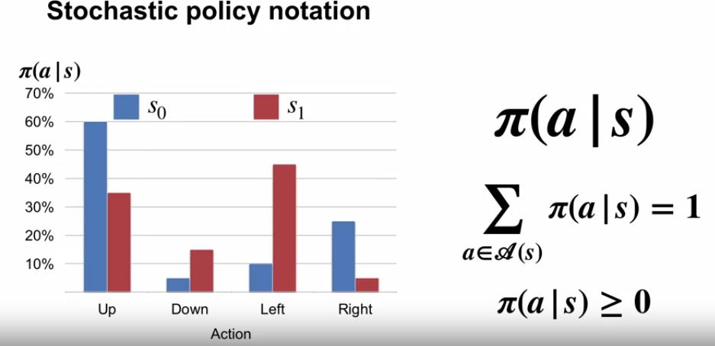

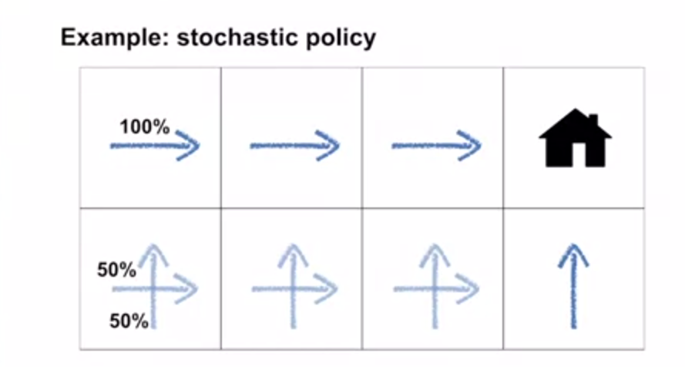 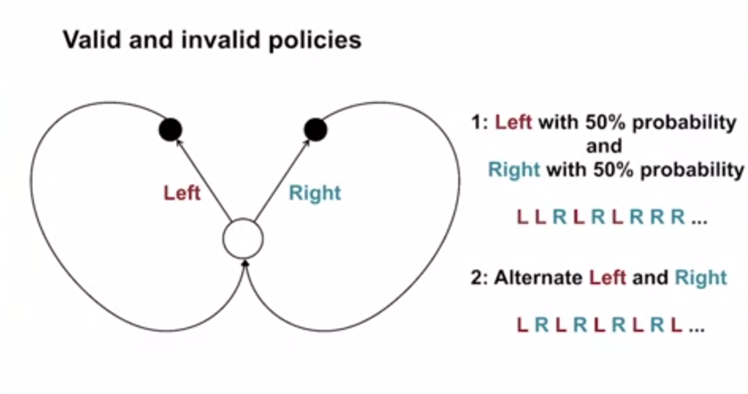 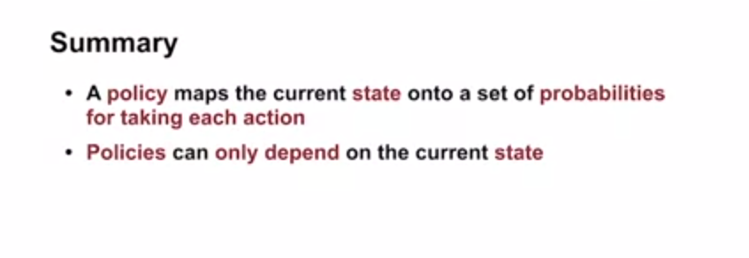

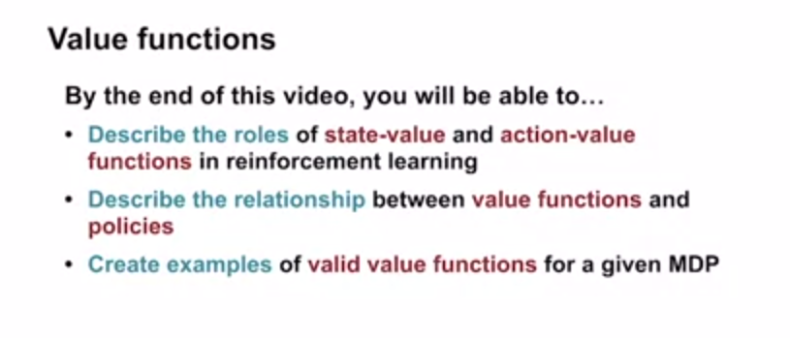

**State-Value function : Future return starting from state S**

**Or**

**Future Expected return from given state**

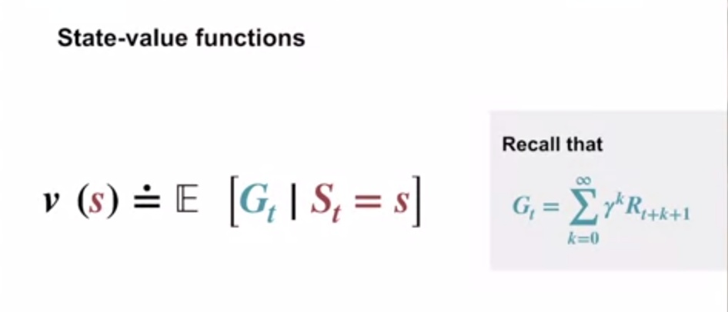

**Action-Value function: what happens if agent starts with action a**

**Or**

**Expected reward if agent selects action and follows policy pi**

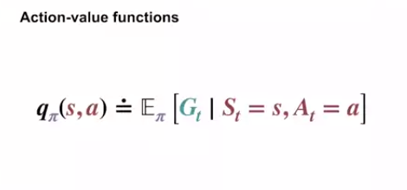

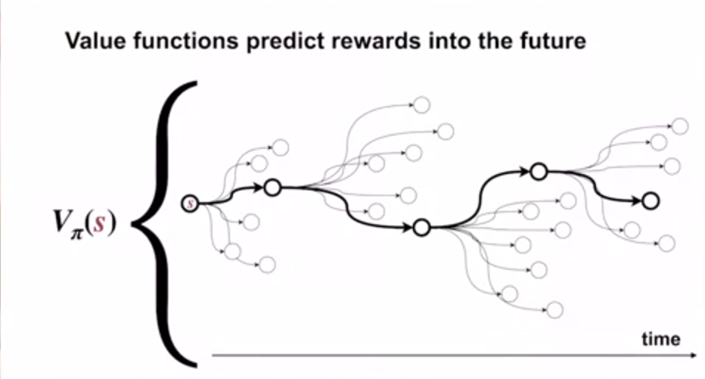

**Note: 1.Value functions enable us to judge quality of different policies (ultimately picking best policy)**

**2.value function summarises all the possible futures ,by avegragin over returns**

**3.**

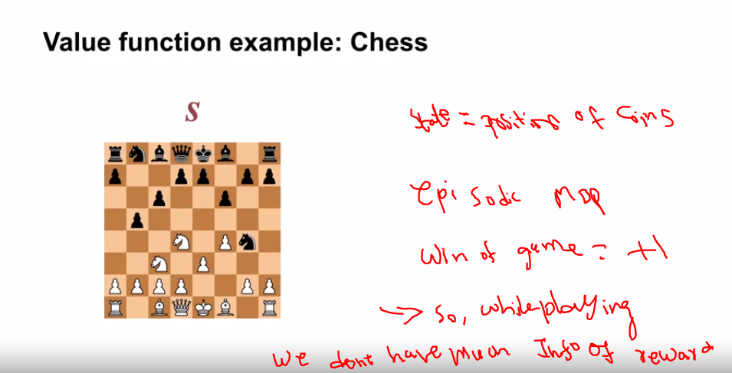

**Hence P(win)=Vpi(S) -🡪Expected sum of all rewards if wee follow Pi**

**Note:Opponent 1 move is treated as state transition**

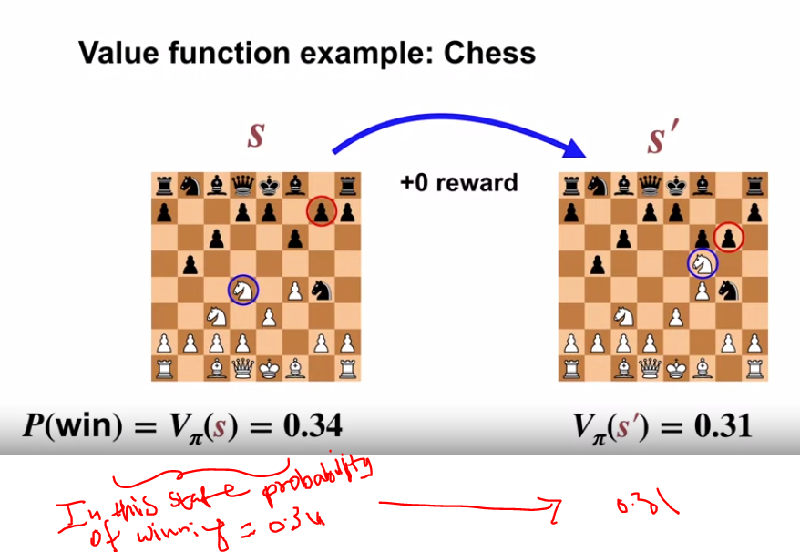

**So in above if you follow policy PI you are less likey win because Expected sum of return is decreasing**

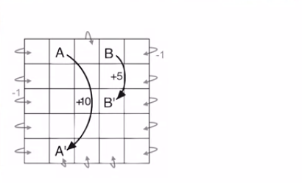

**Basically we need to estimate states of each grid ???**

**Note:Every action in state A gives +10 reward and state B any action gives reward +5**

**2.every action in A transition to A1 and b to B1**

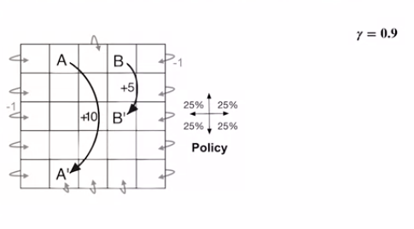

**Lets say state value function for now they gave ontsead we finding**

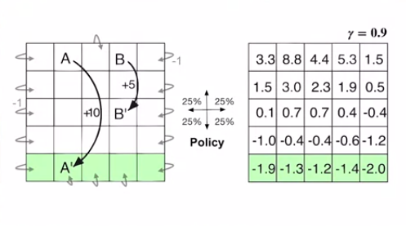

**In the end the grid values are summariesed by state-action** 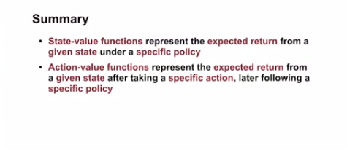

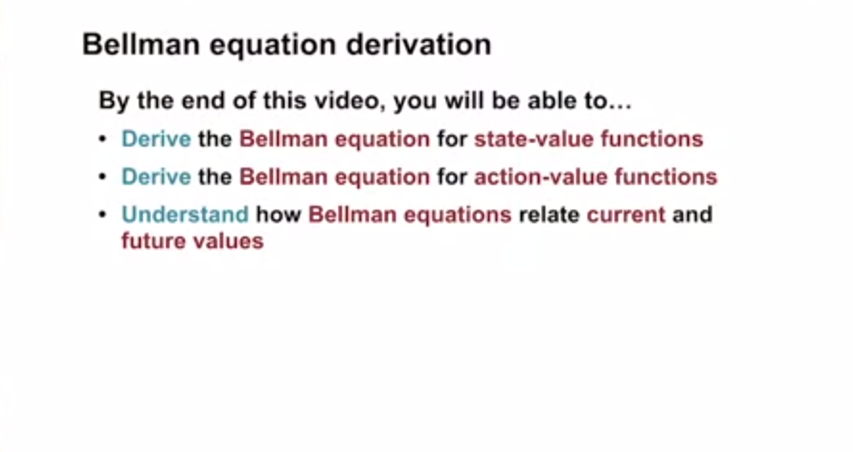

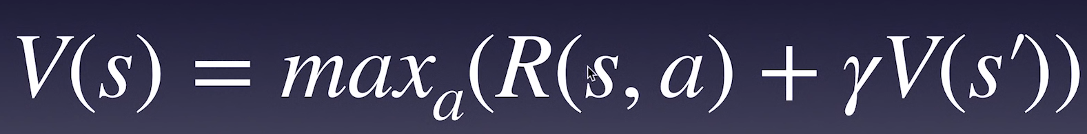

If Gamma =1 (with no discount)

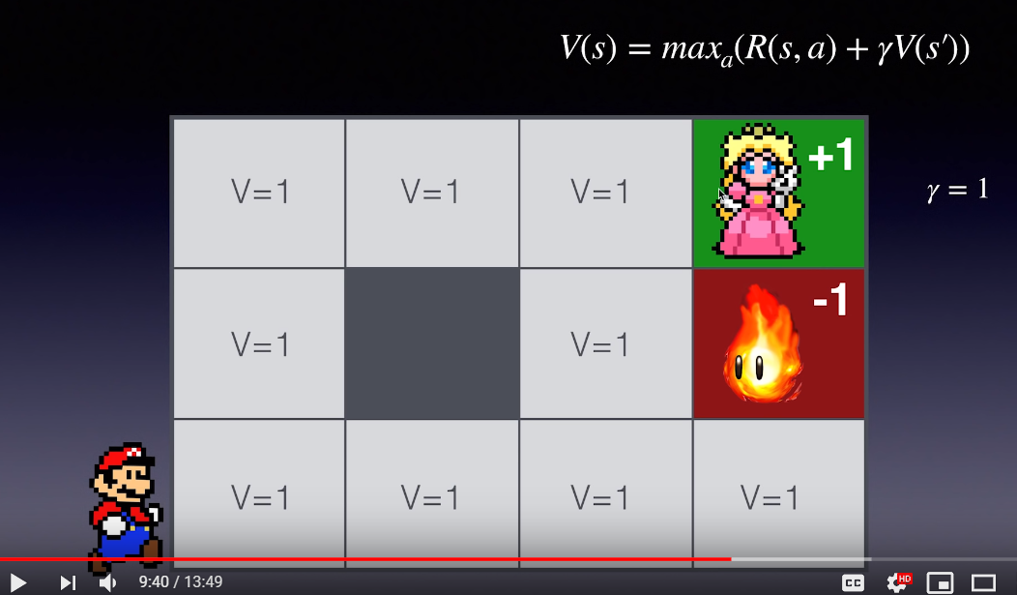

Lets use discount factor

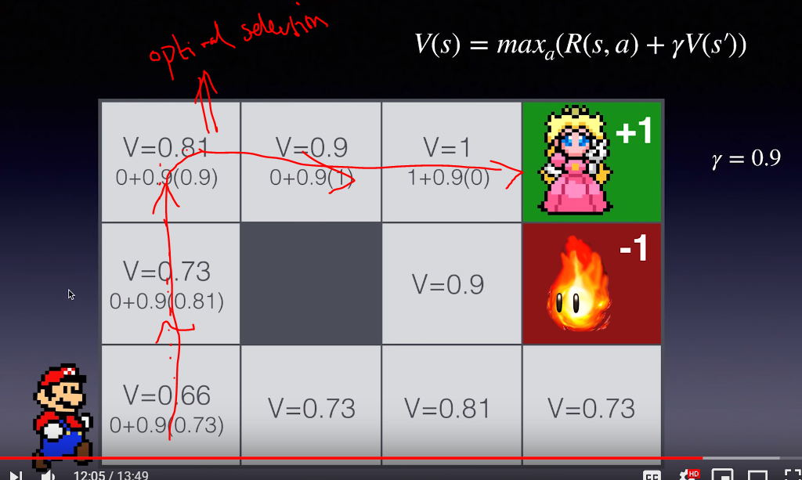

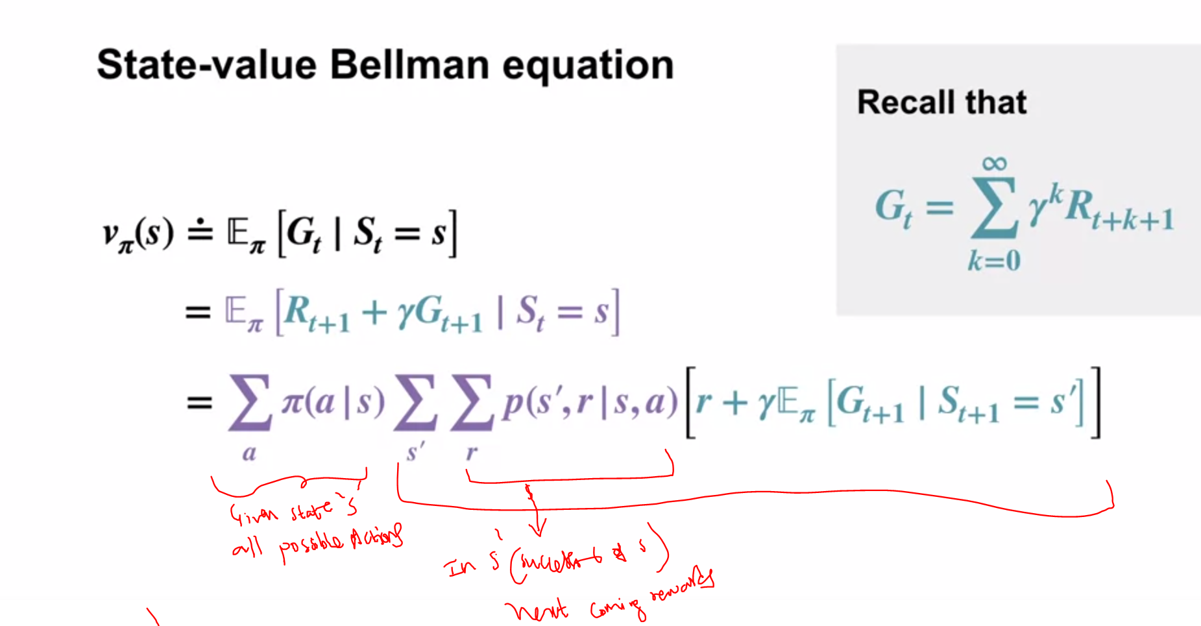

Expanding to next states s11 and further states to infinity

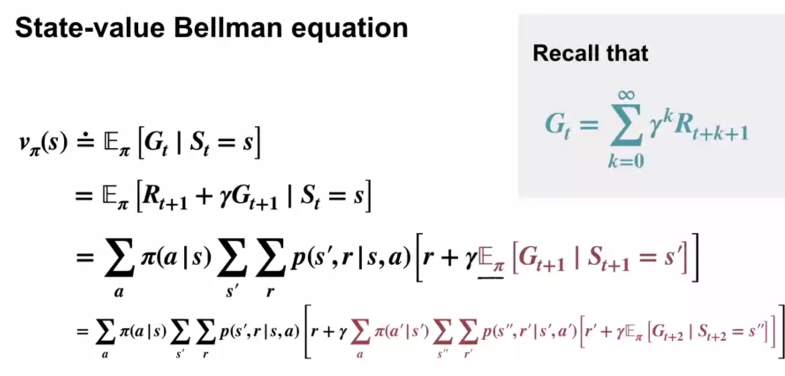

**Lets say we represented vpi(s) as avergage of infinite no:of all futures**

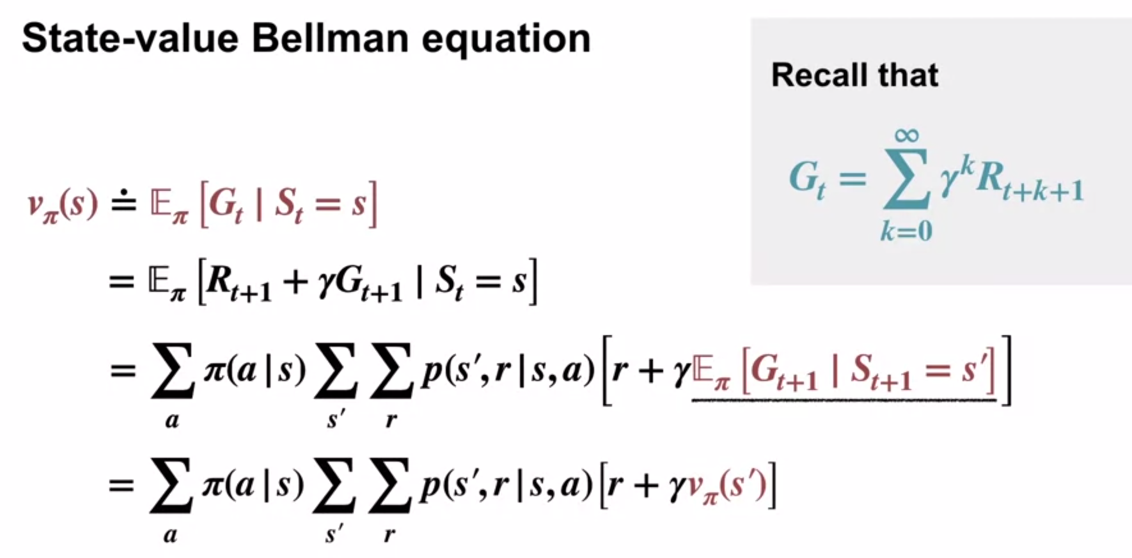

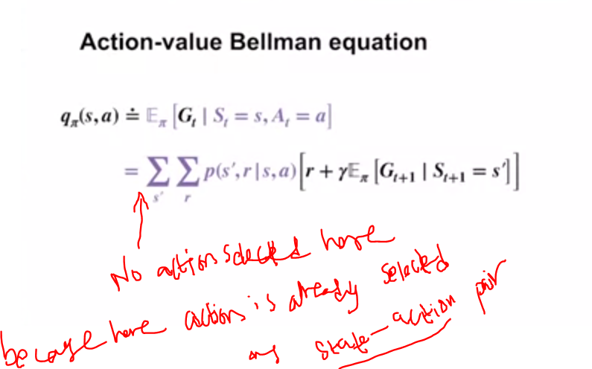

**Warning:we cant stop the quation like previous state-value equation.**

**That bove is for 1 state-action pair.**

**Now lets recursively wirtedown further state-action pairs**

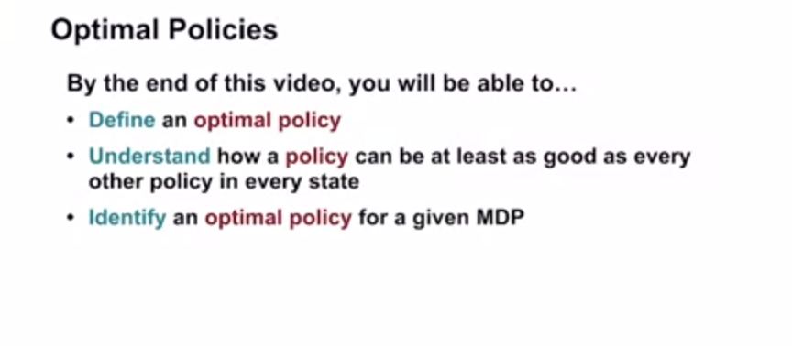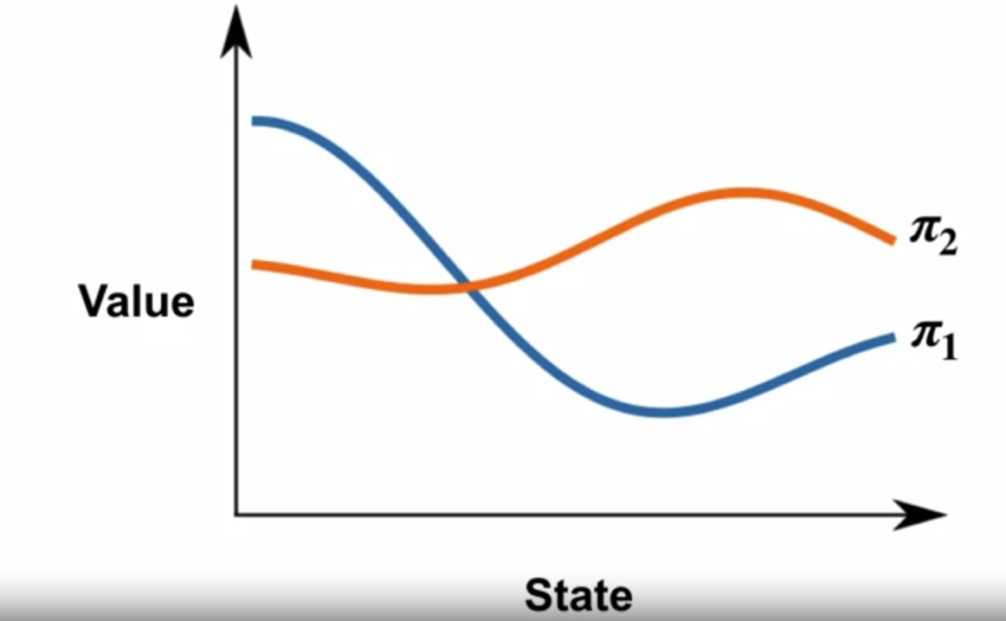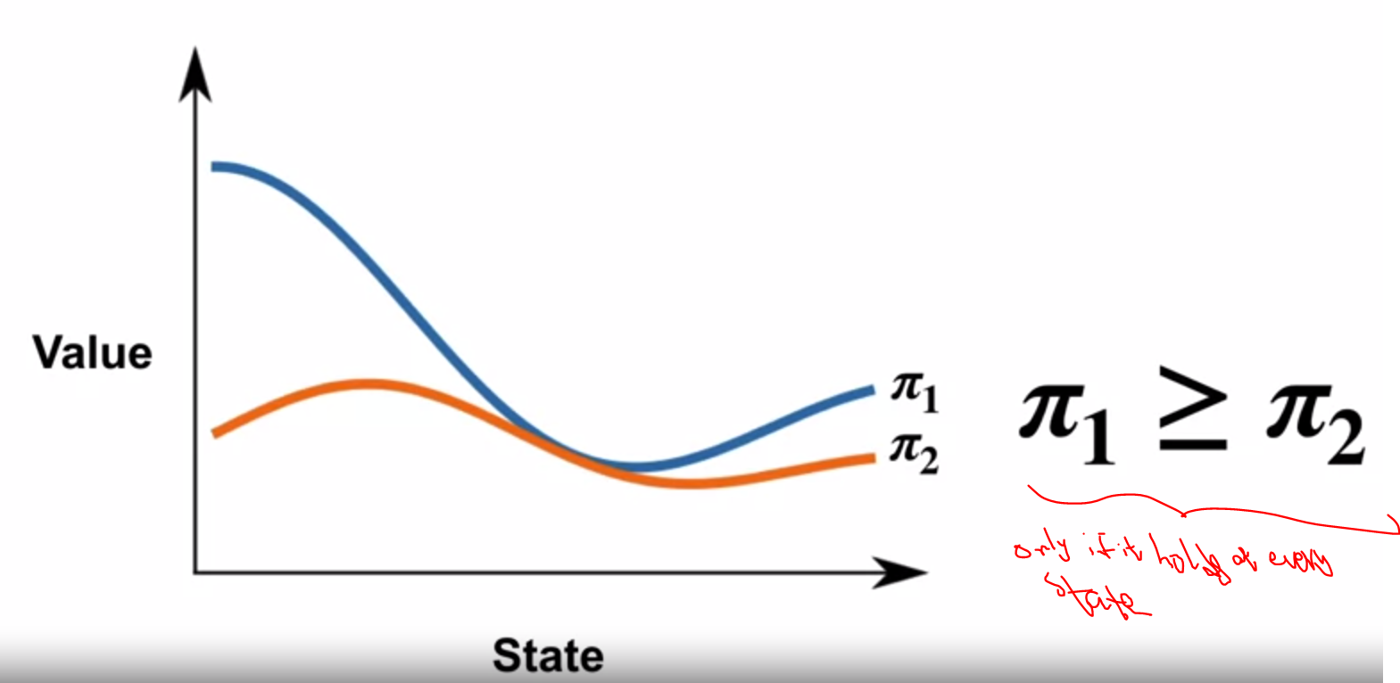

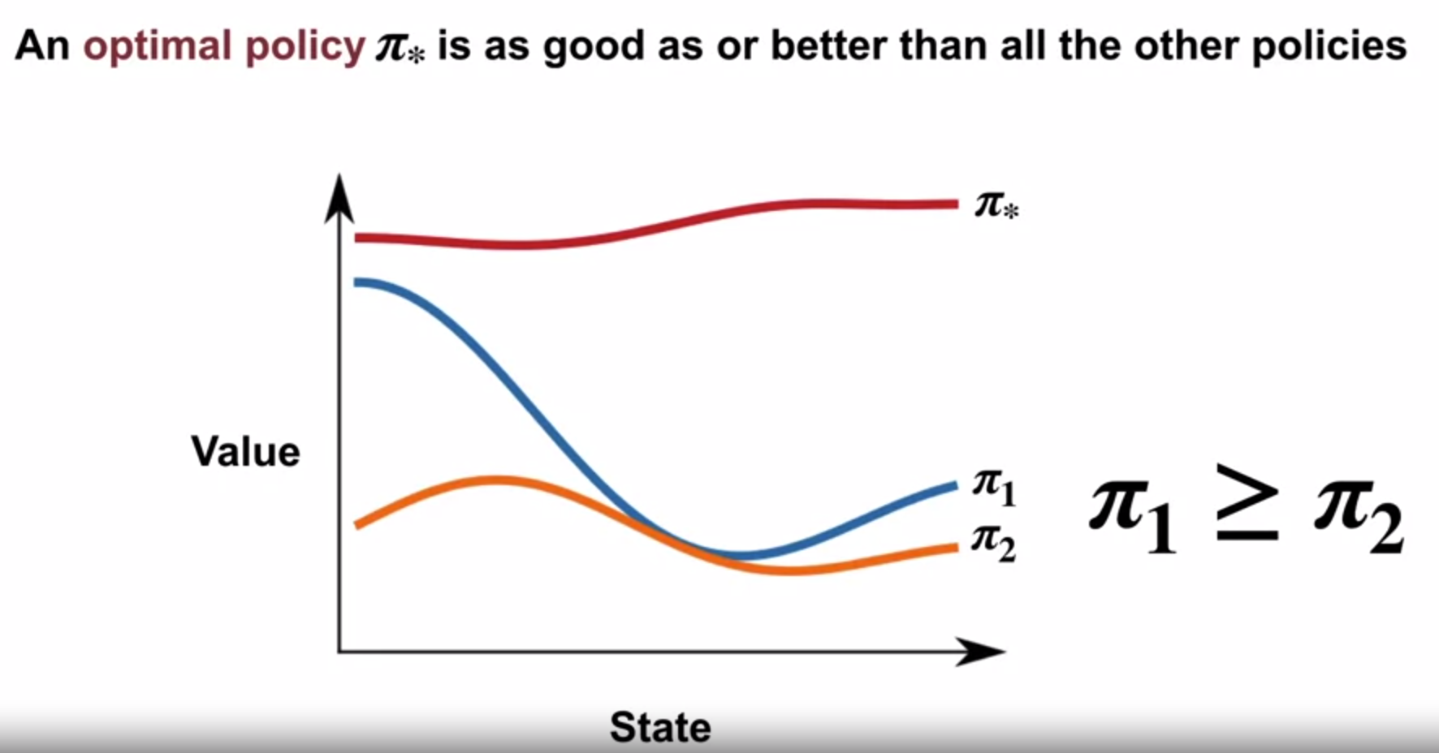

**When no policy is high through the entire states ??**

**Sol:we mix or consider 3rd policy which is combination of policy when high**

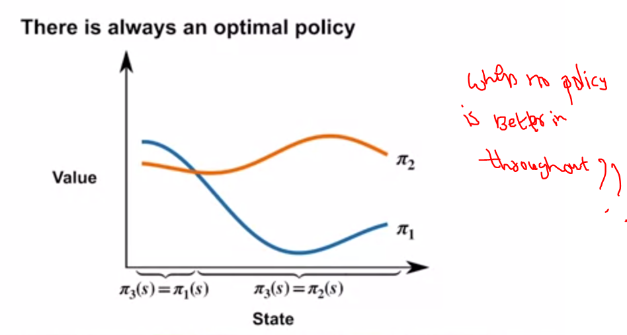

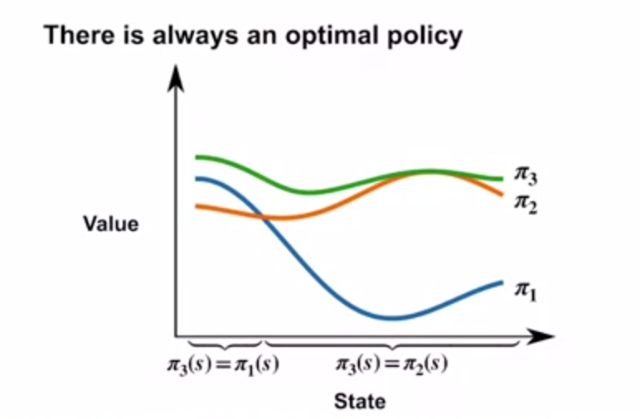

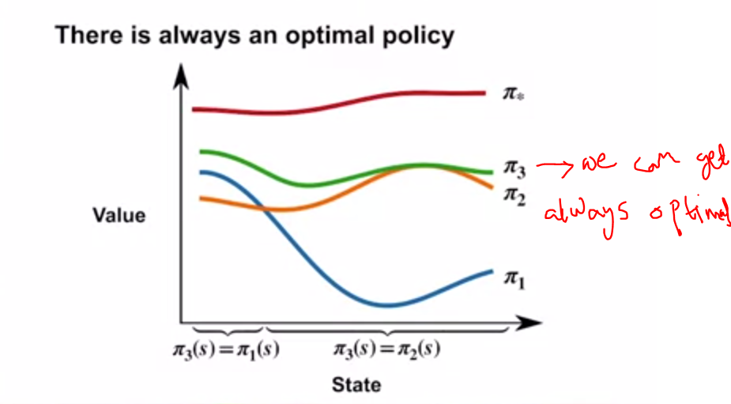

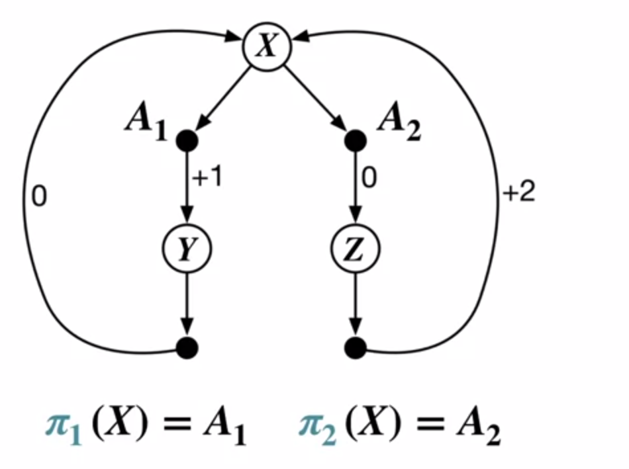

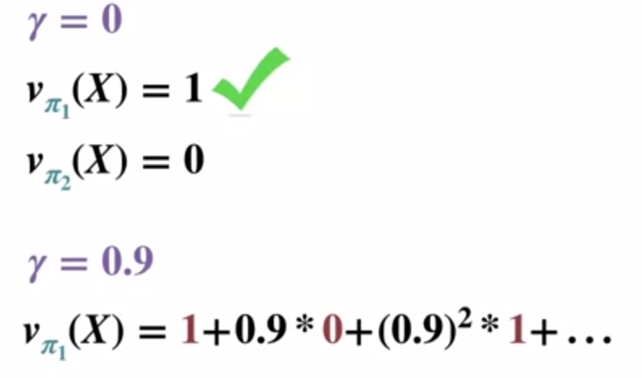

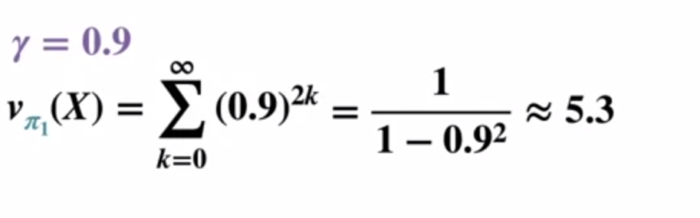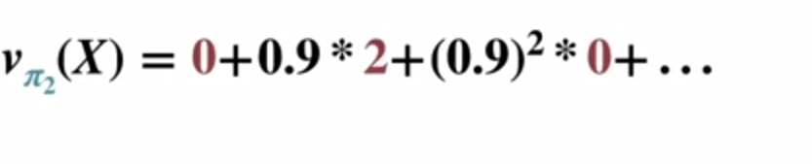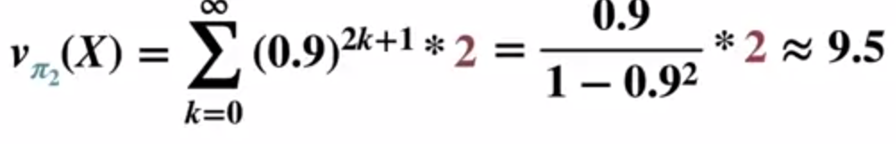

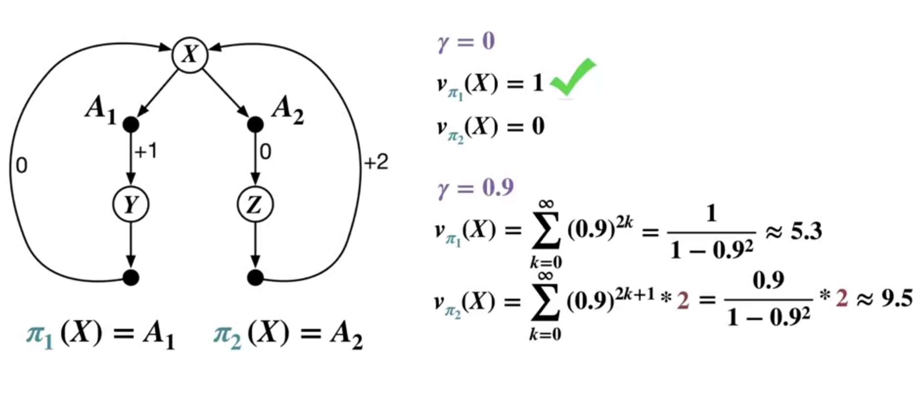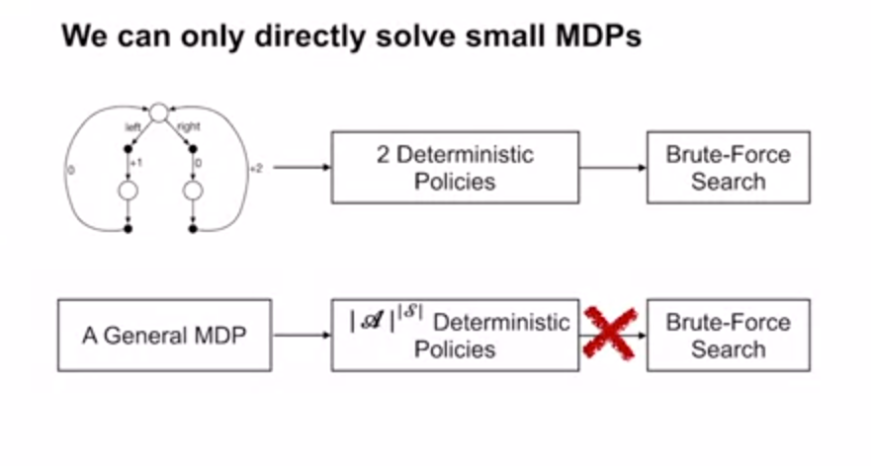

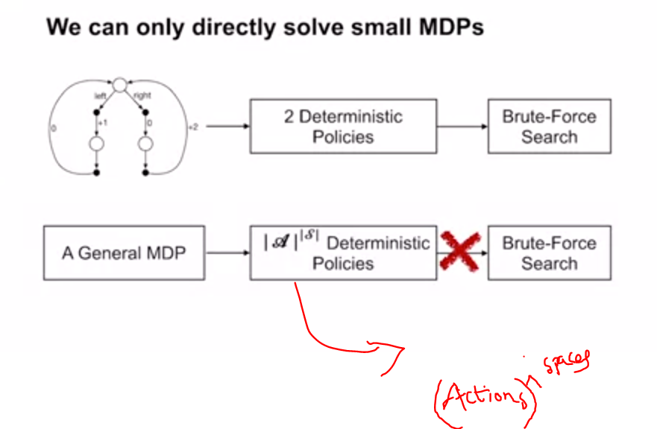

**Very difficuly to compute all deterministic policies and evaluate optimal policy**

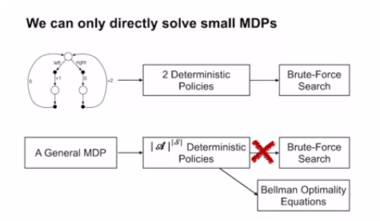

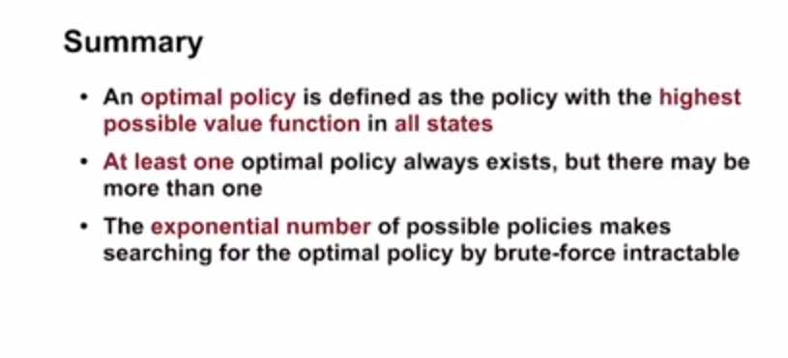

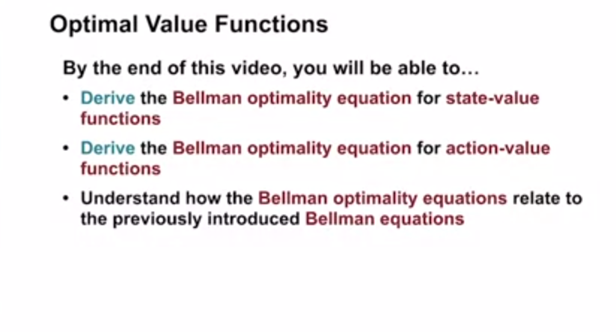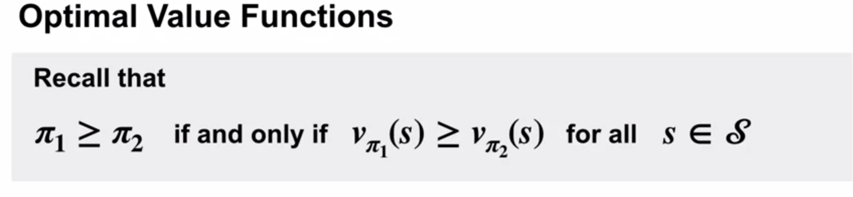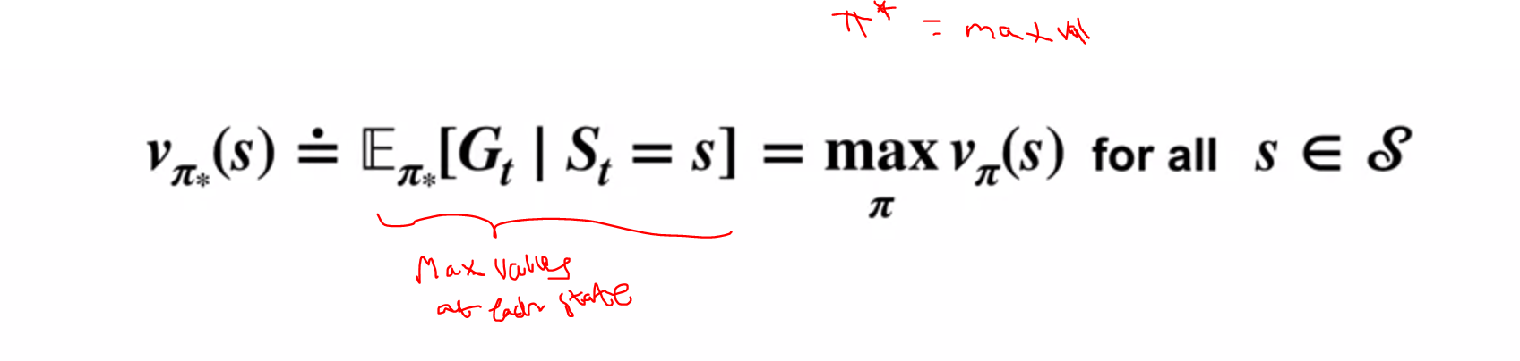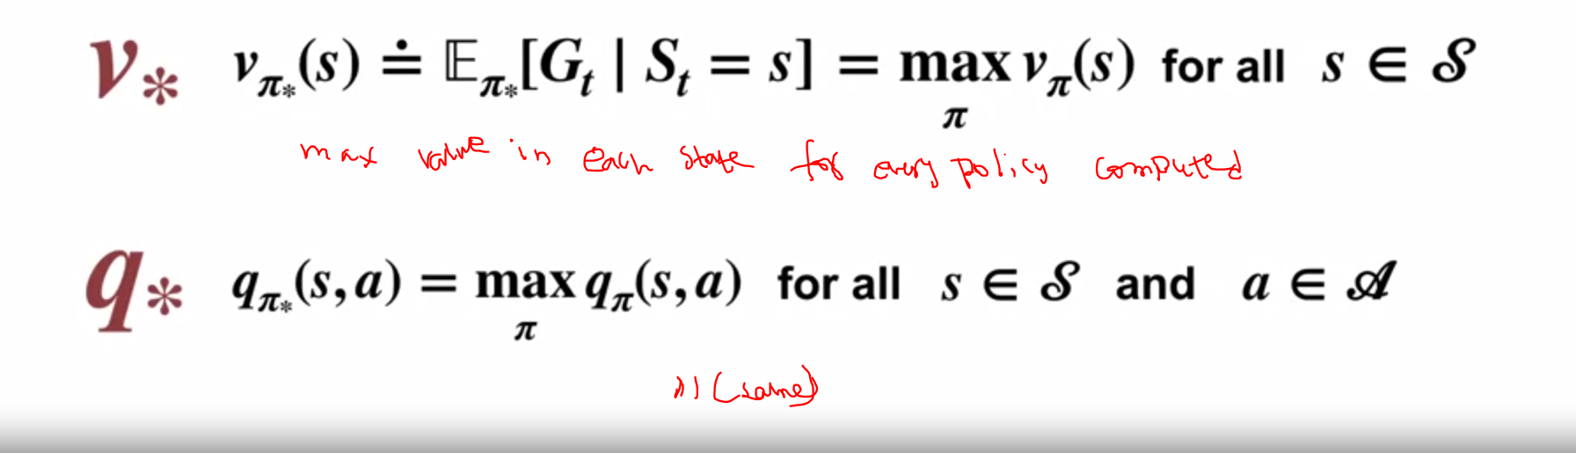

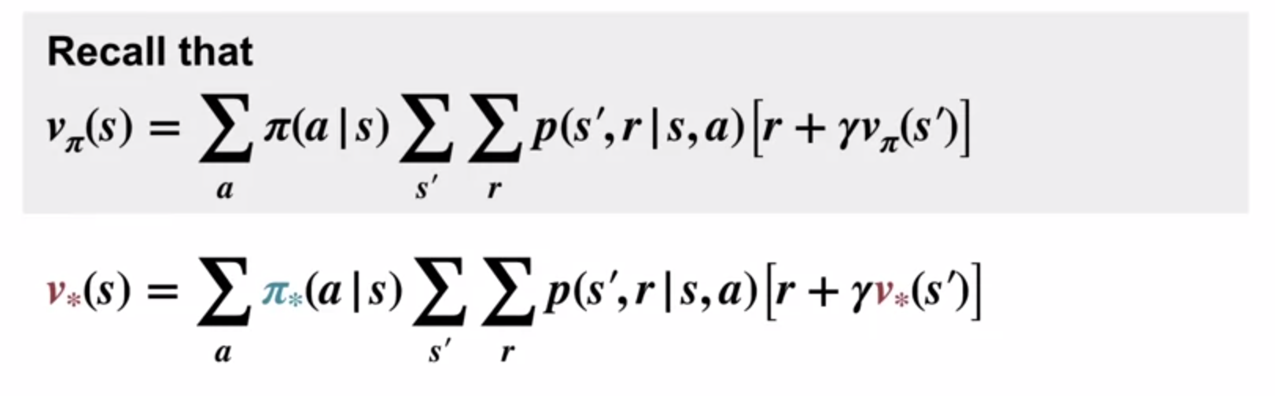

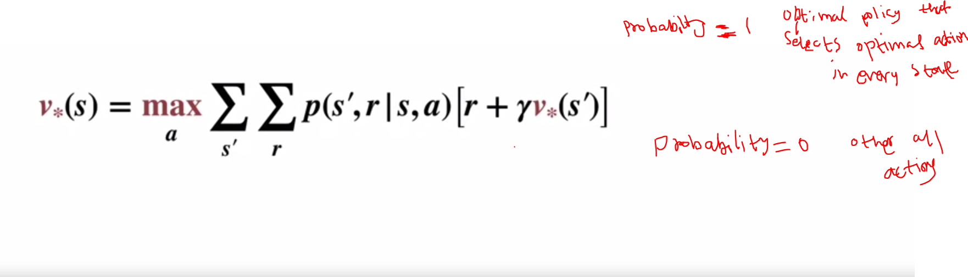

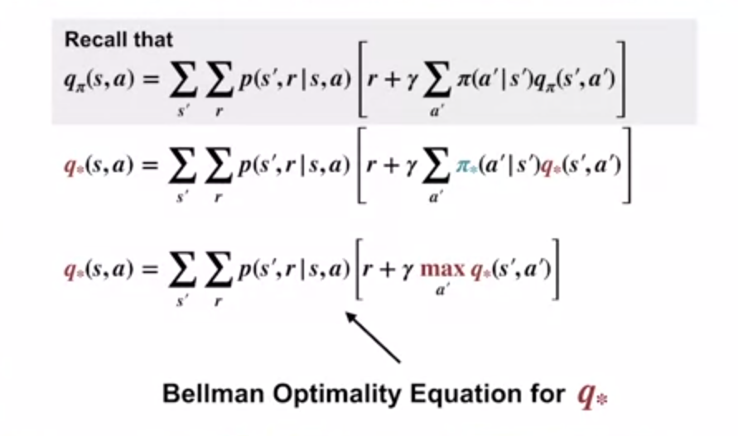

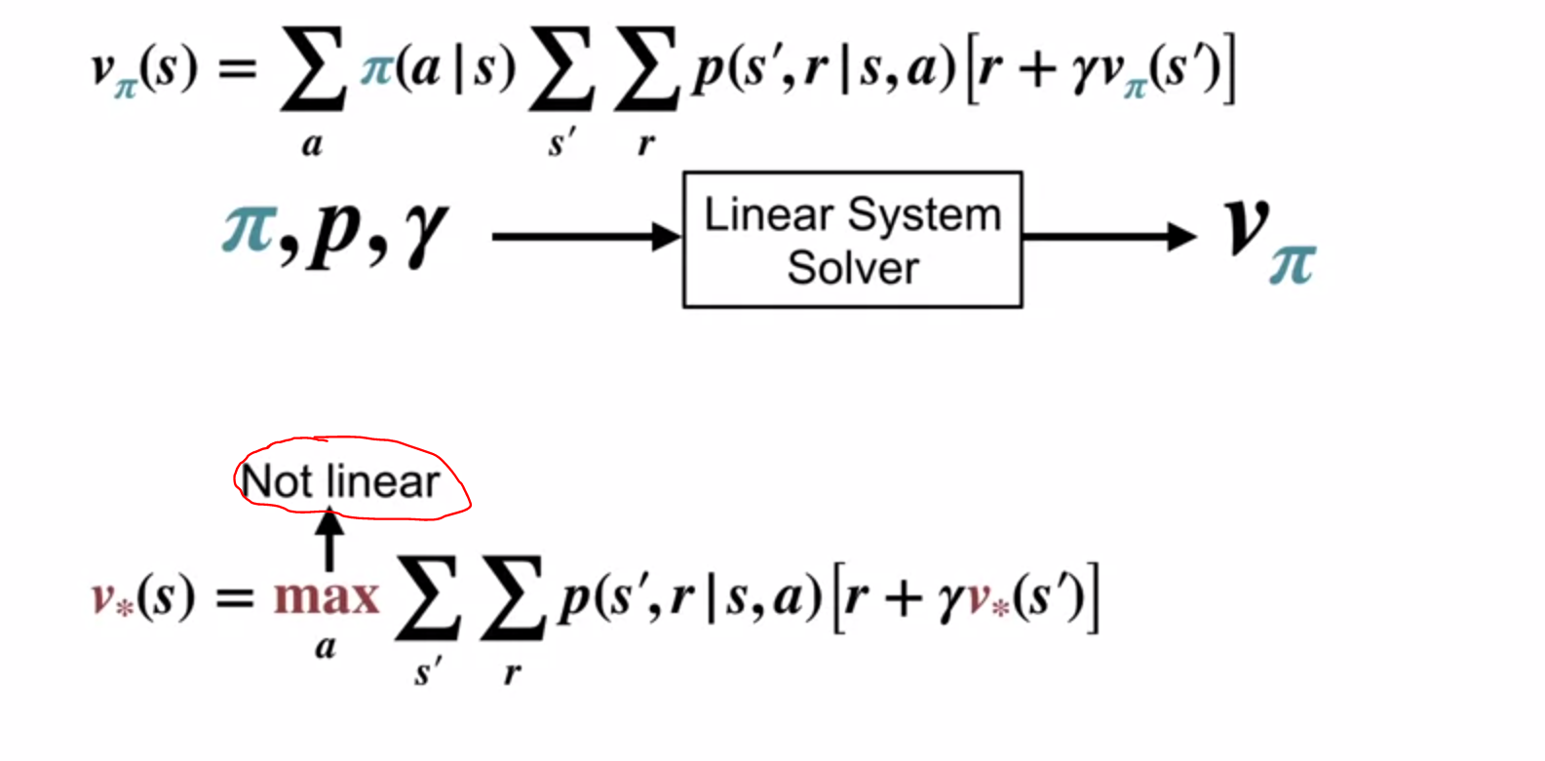

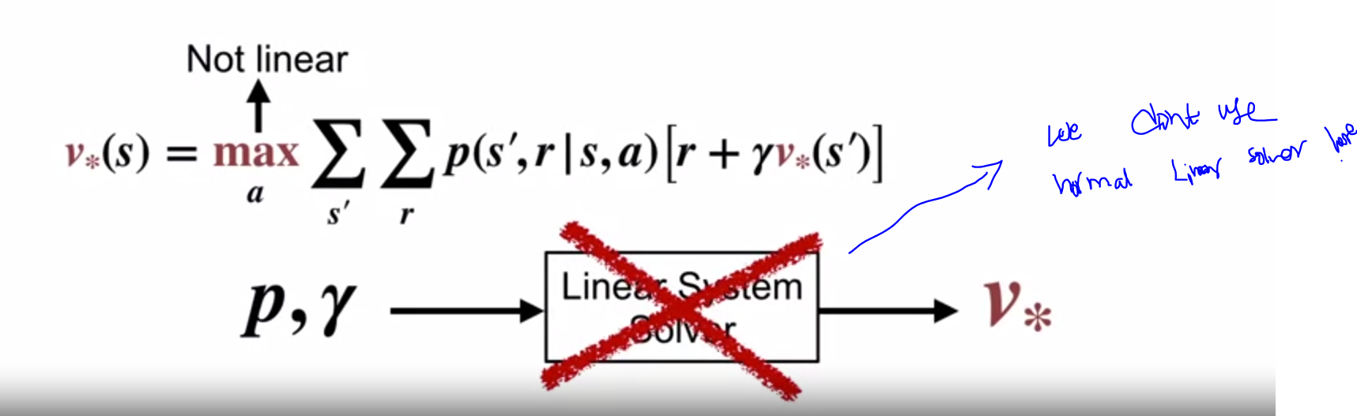

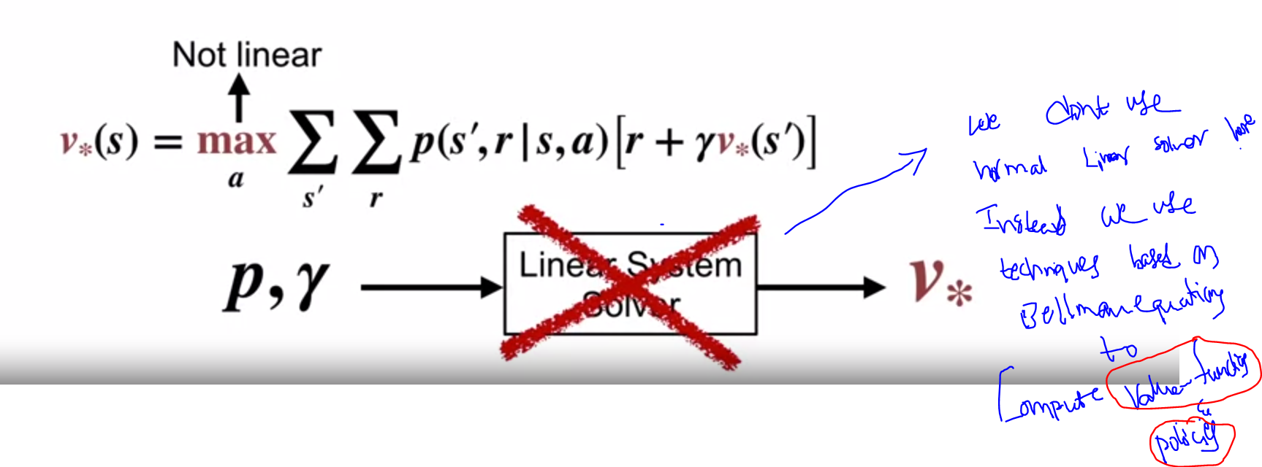

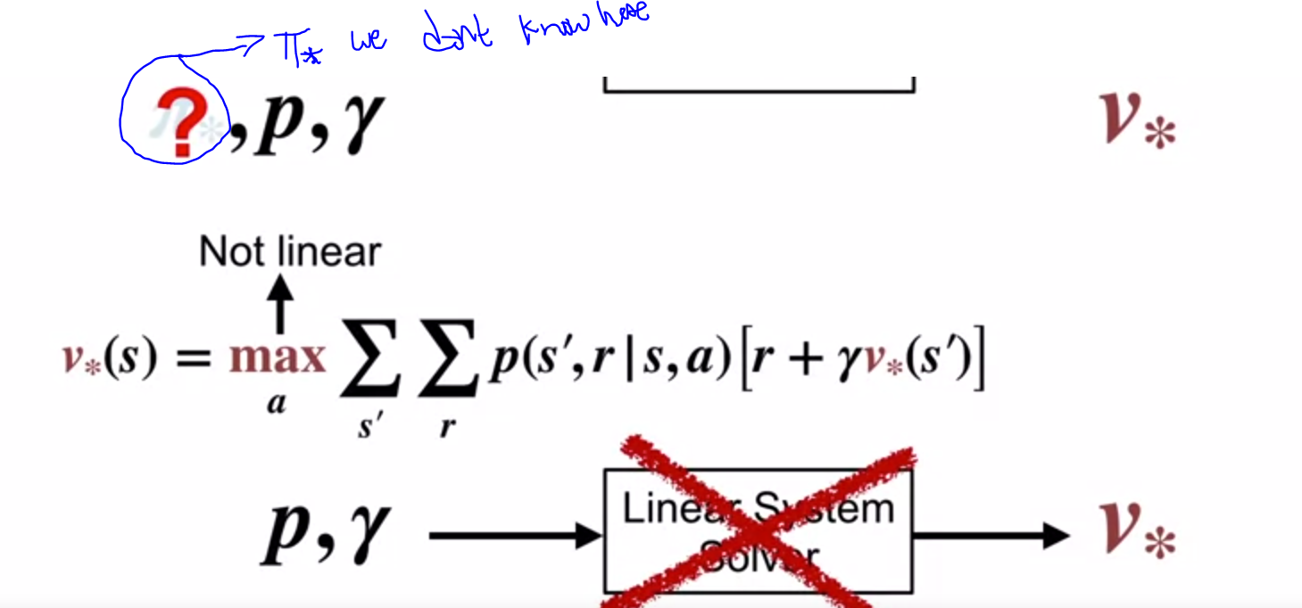

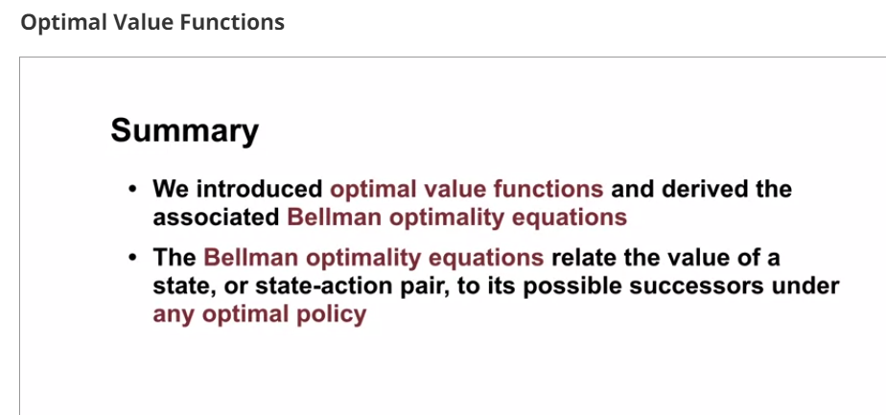

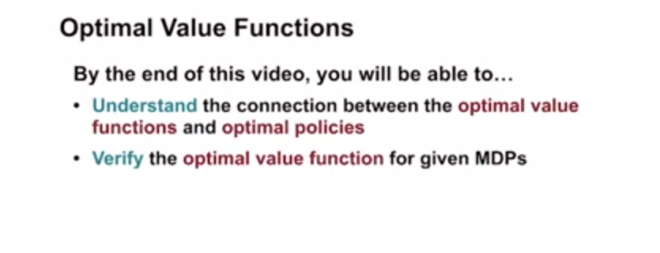

**Big Picture: Our end goal is not finding optimal value function but instead we have to find optimal policy itself**

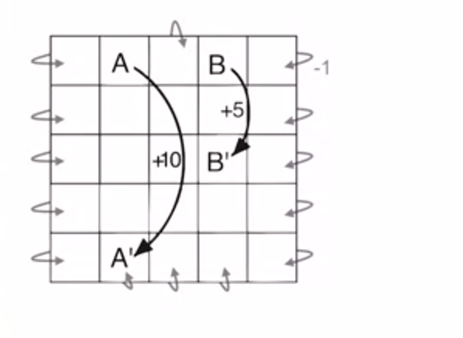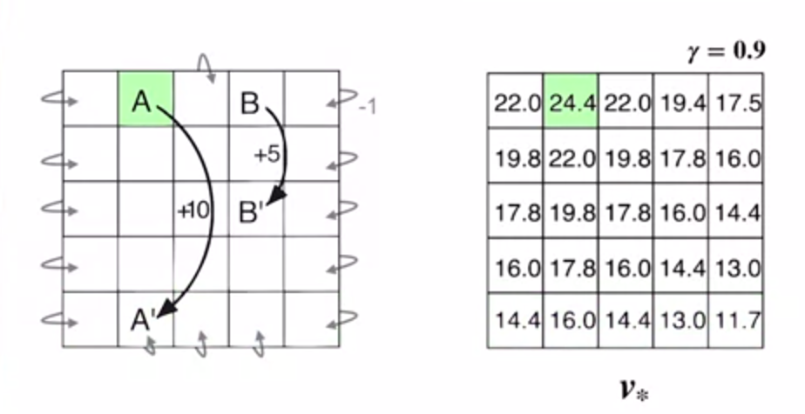

**Observe difference between uifrorm rewards vs optimal policy**

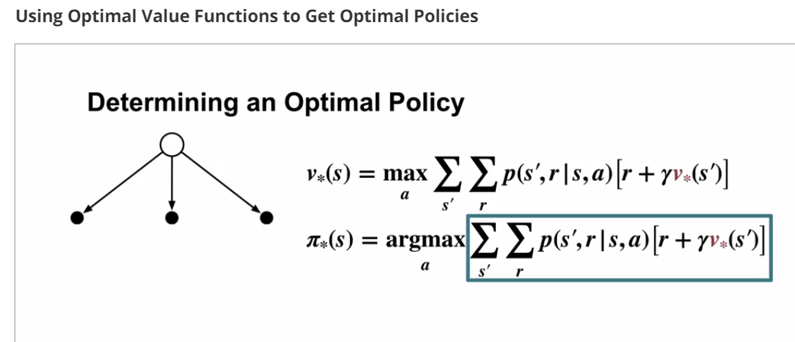

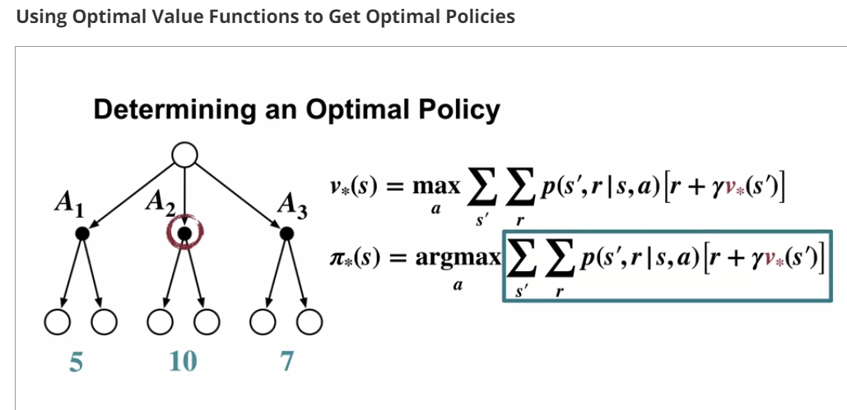

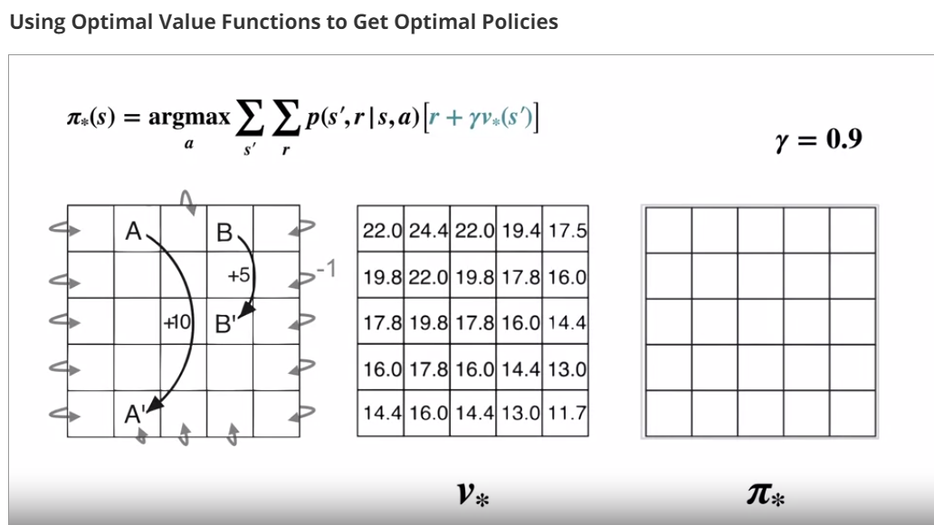

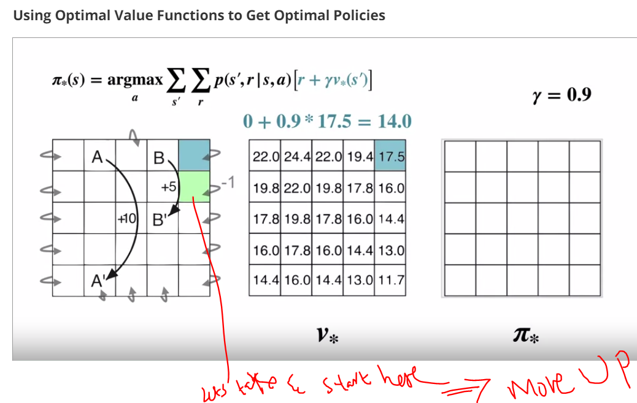

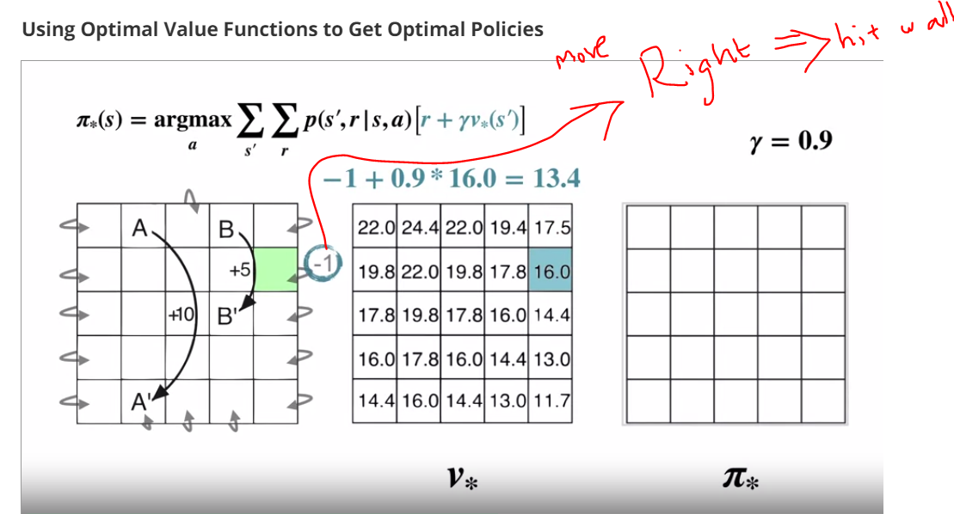

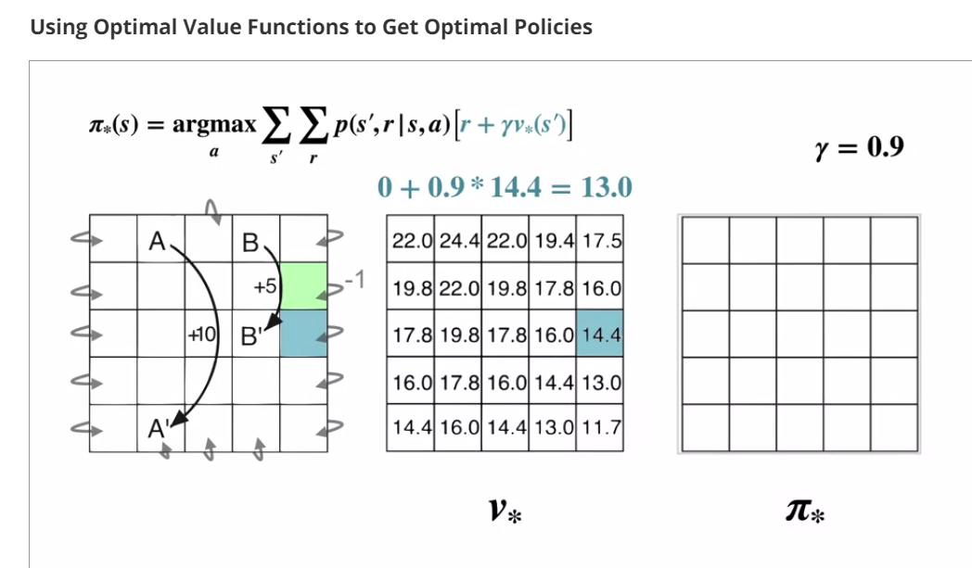

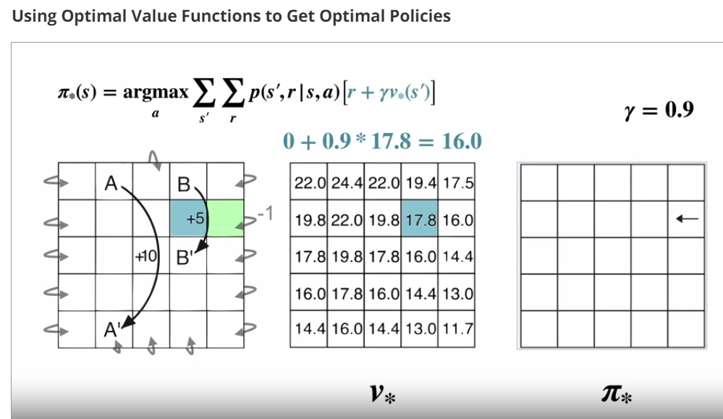

**Out of 3 actions ,16(move left) is higher so.In Green state moving left should be selected by any optimal policy**

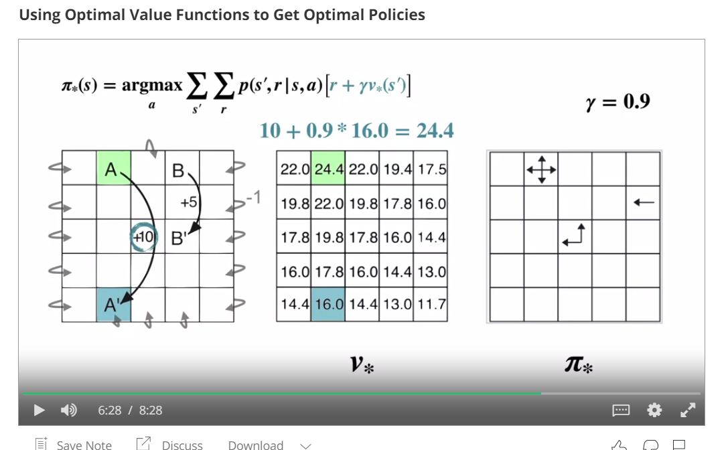

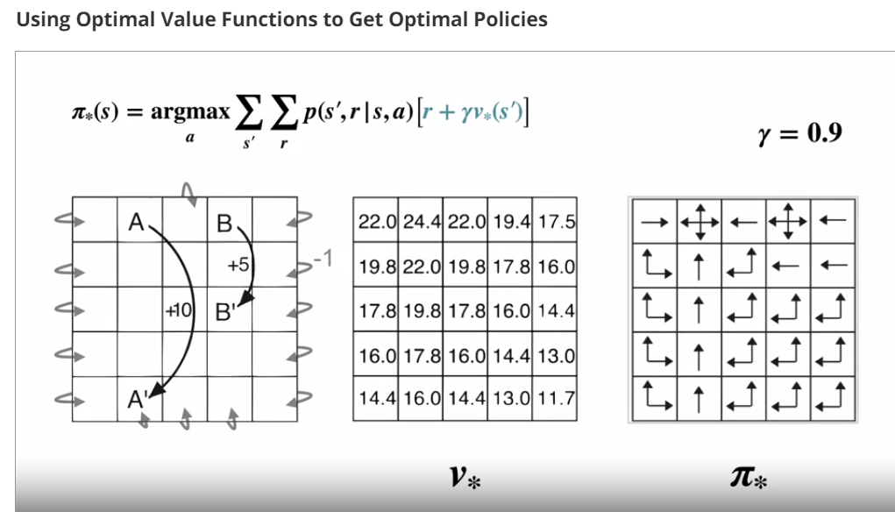

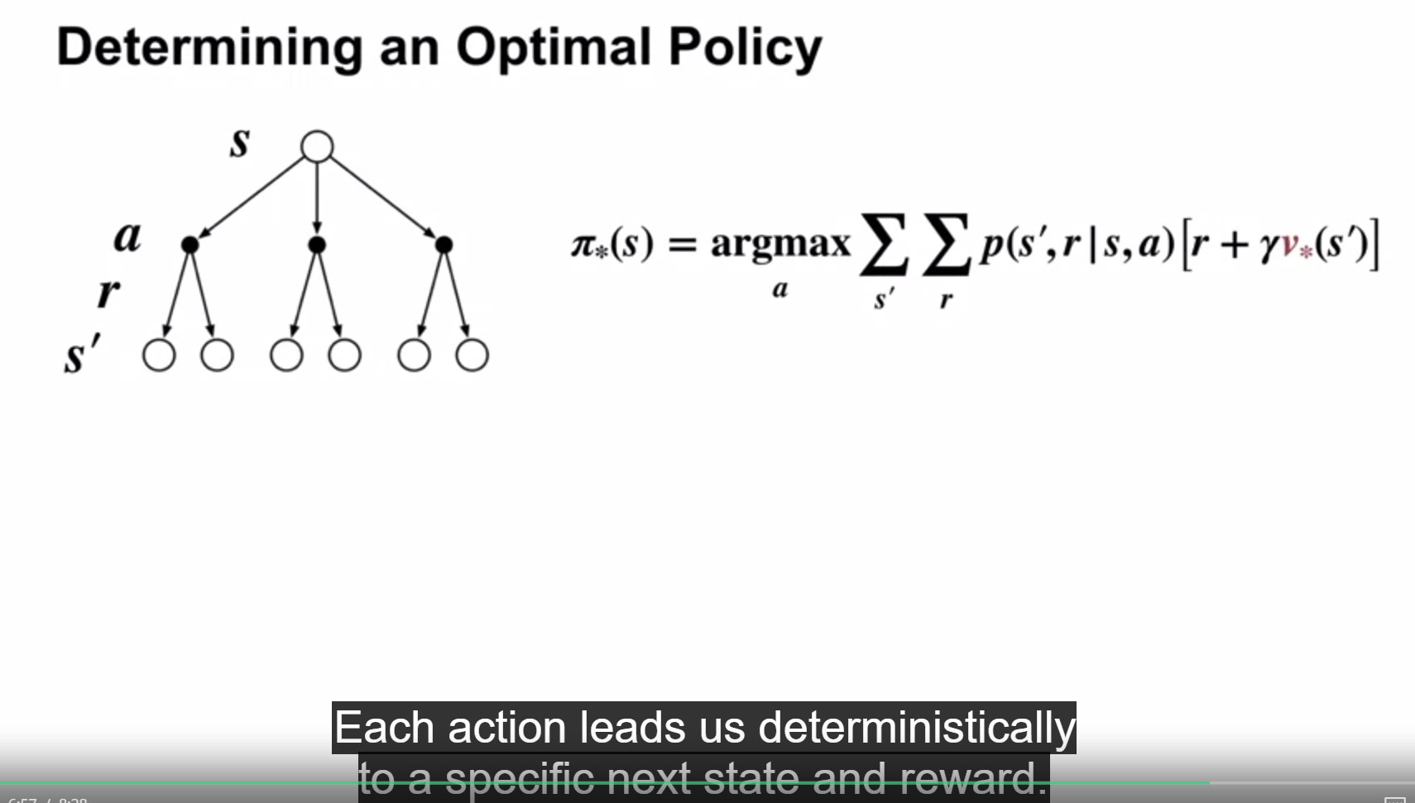

**Big Picture:**

**In end each action leads us to specific next state S‘.**

**SO we only have to evaluate one transition per action.**

**Eg:In previous pictures when we took eg of green state we had 3 actions,But out of 3 actions only one action is higher reward.so only that action we take.**

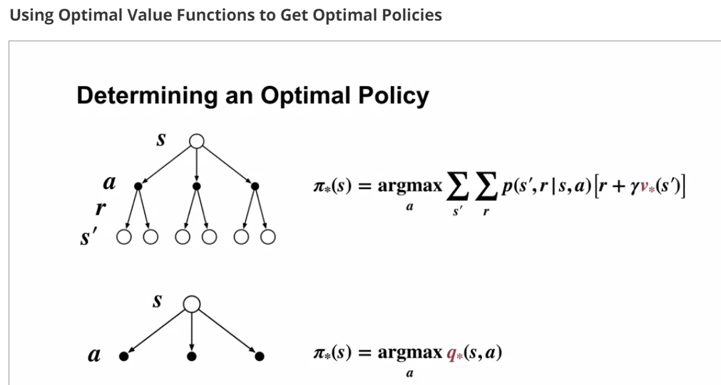

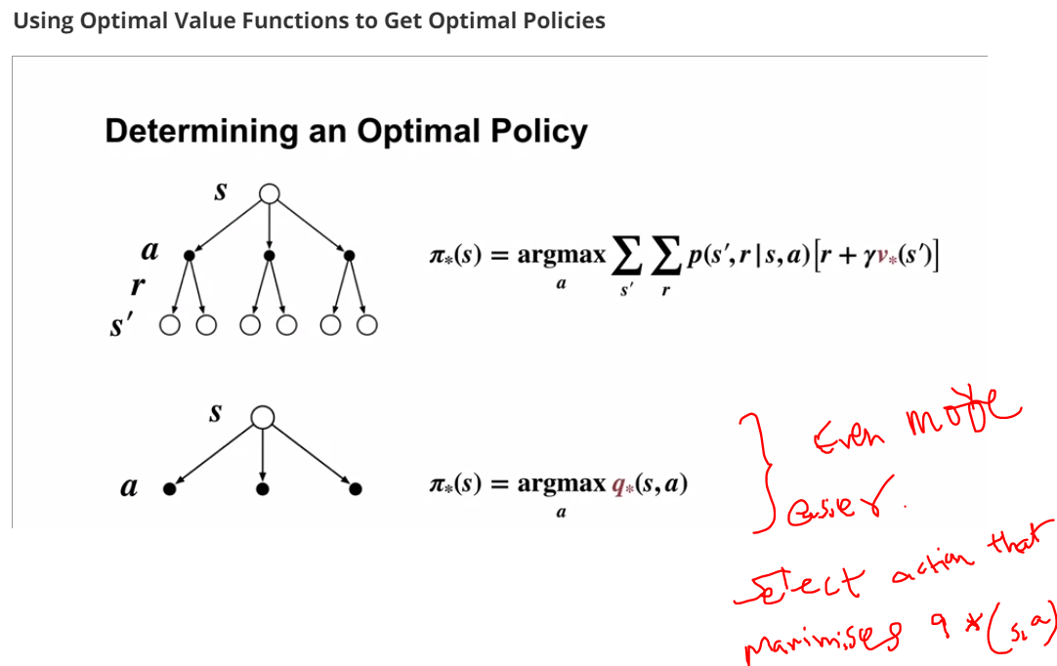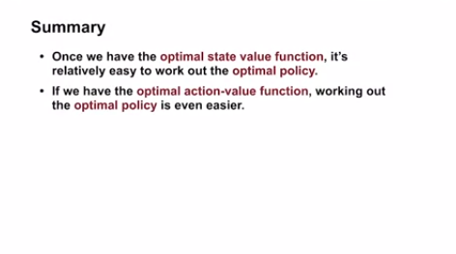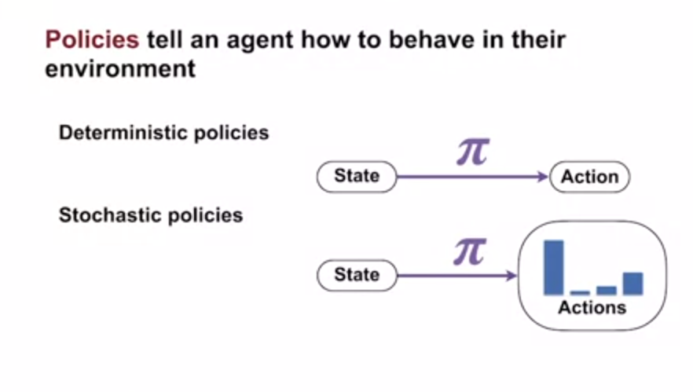

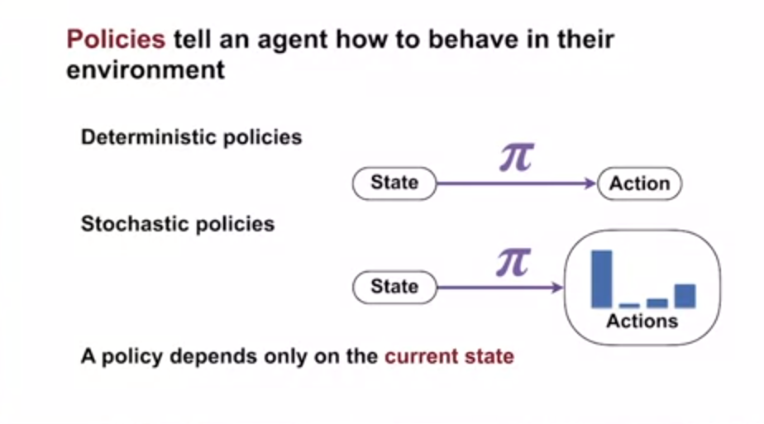

**Value functions are 2 types 1.state-value and 2.actin value functions**

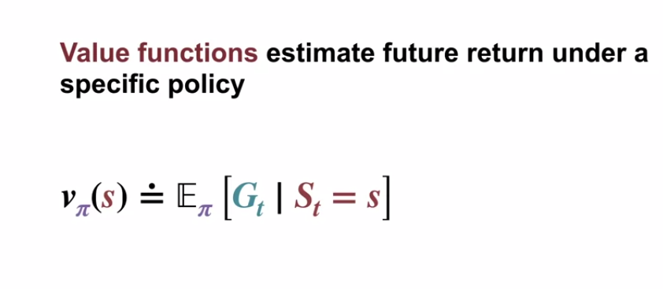

**State value functions gives expected return from the current state under a policy**

**Action value functions gives expected return from the current state S if agent first select action A and follows Pi after that .**

**Note: value functions simplify things by aggregating many possible future returns in to single number.**

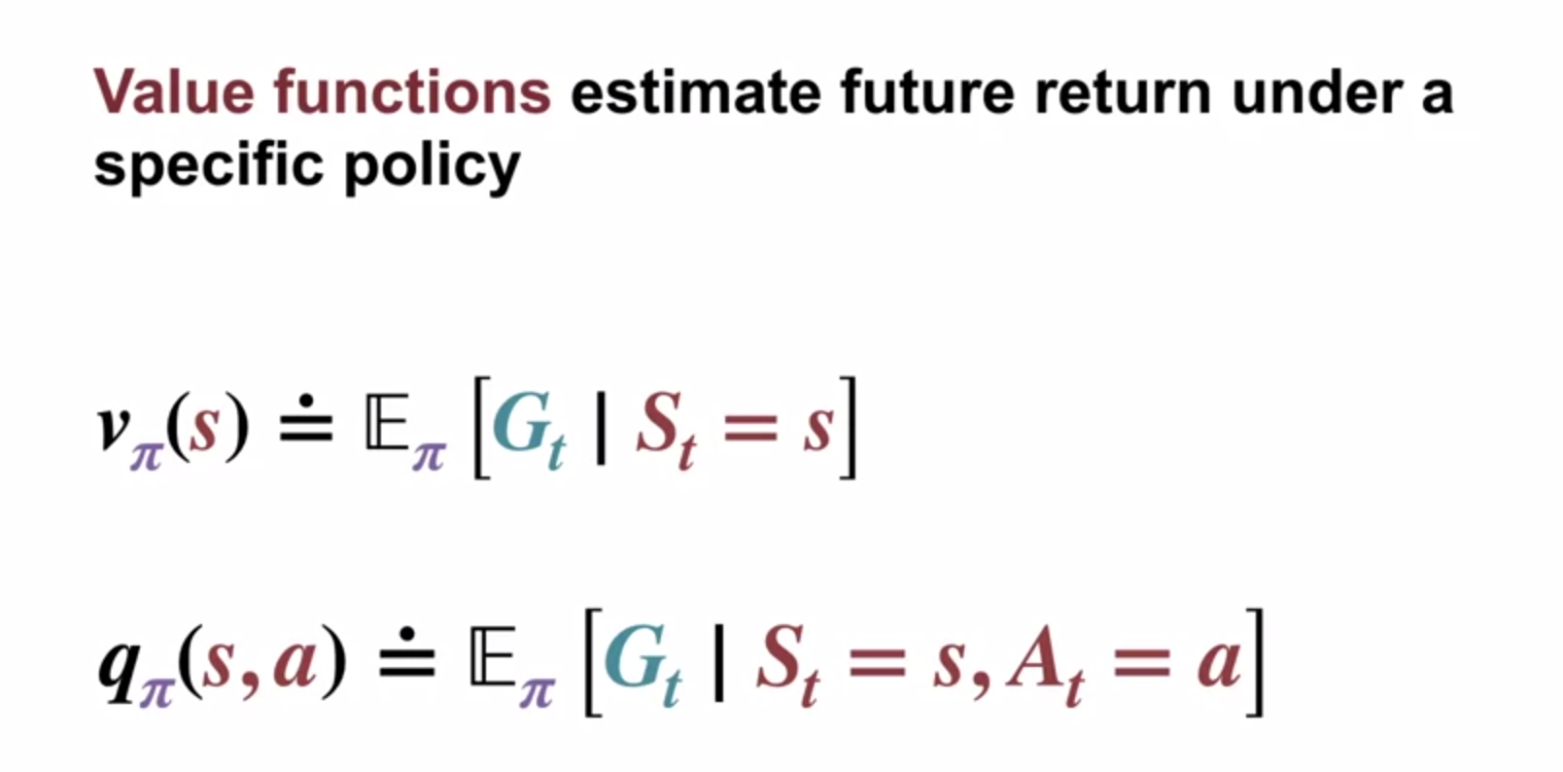

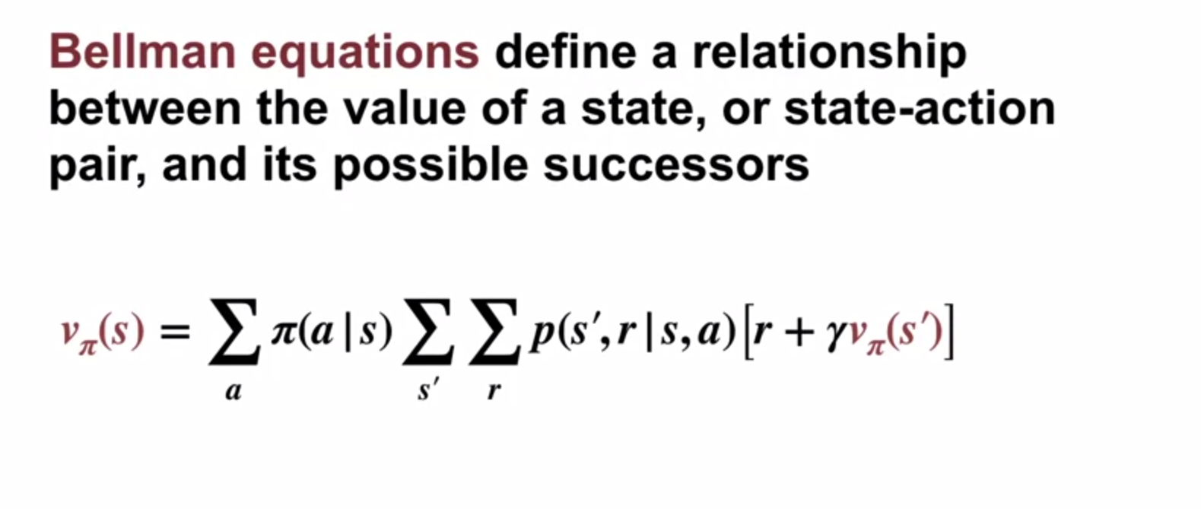

**Bellman equation for state-value funtion gives value of current state as sum over the values of all successor states and immediate rewards.**

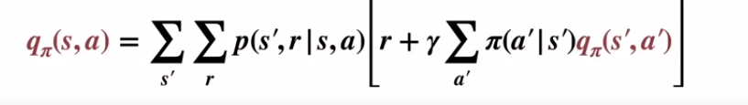

**Bellman equation for action-value funtion gives value of particular state-action pair as as sum over the values of all possible next state-action pairs and rewards.**

**Note:**

**1.Bellman equations can be directly solved to get value functions**

**2.Bellman equaions helps us in evaluating policies**

**3.But they do not yet aci=hieve out ultimate goal to find a ploicy that attains as much reward as possible.**

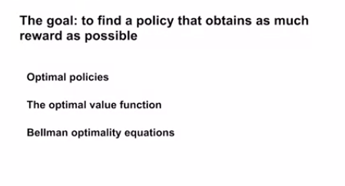 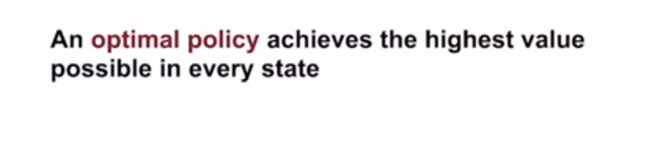 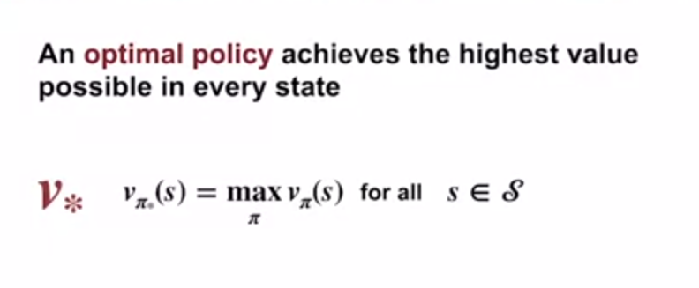

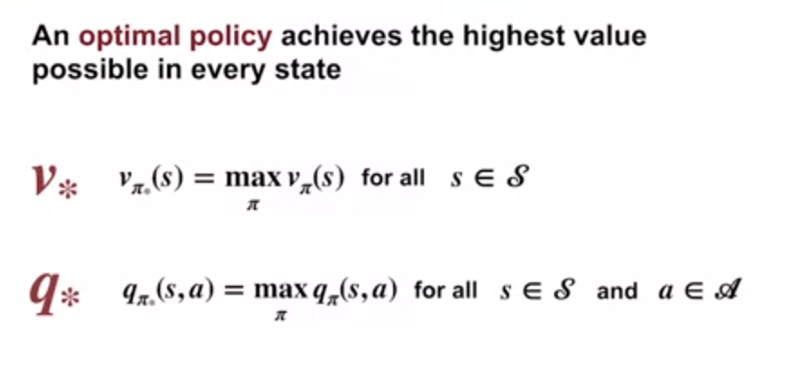 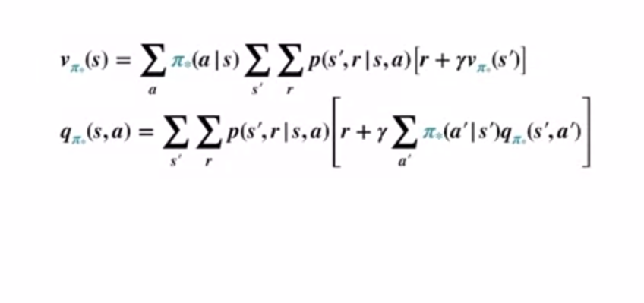

Change to

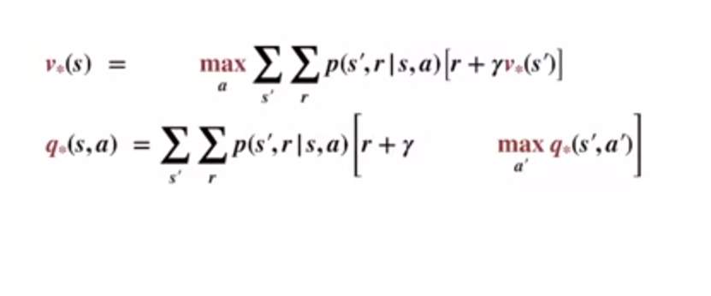

**Note:**

**1.The optimal policy must always select best available option**

**2.We can extract optimal policy from state-value functions.But to do so we need 1-step deynamics of MDP**

**3.we can get optimal policy more a=easily if we have state-action value functions**

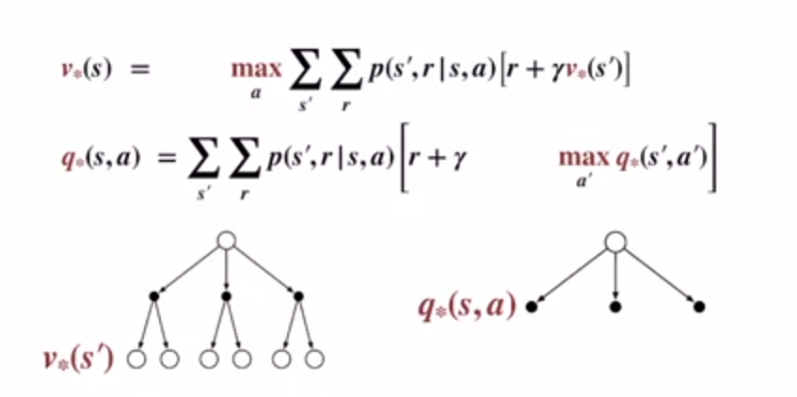

**QUIZ**

